**ASSIGNMENT 2**

Name: Shravani Laxman Salaskar

**Issued by:** Digisuraksha Parhari Foundation

**Submission Deadline: 28th April 2025**

**Labs**

1. **KRYPTON** – https://overthewire.org/wargames/krypton/

Tool: Krypton done in Command Prompt

* Krypton Level 0 → Level 1

Step 1: Encrypt the code “S1JZUFRPTklTR1JFQVQ=” to get the password. Use Cyberchef -> From Base64 -> Paste the code -> code is generated .

Founded PW: KRYPTONISGREAT

Step 2: Use the password to login

* Krypton Level 1 → Level 2

Step 1: Enter ssh -p 2231 [krypton1@krypton.labs.overthewire.org](mailto:krypton1@krypton.labs.overthewire.org)

Step 2: Enter the password found

Step 3: Read the instruction provided properly and enter the commands to get the password for next level.

Logic behind the solution: Encrypted the ciphertext to plaintext using cmd commands.

Pw found :ROTTEN

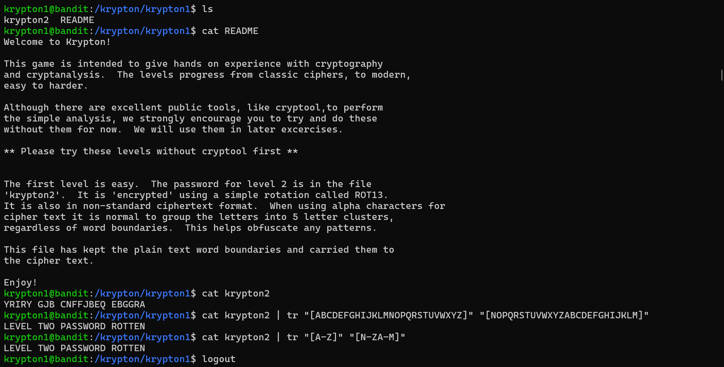

* Krypton Level 2 → Level 3

Step 1: Enter ssh -p 2231 [krypton2@krypton.labs.overthewire.org](mailto:krypton2@krypton.labs.overthewire.org)

Step 2: Enter the password found

Step 3: Read the instruction provided properly and enter the commands to get the password for next level.

Step 4: Ceaser cipher meaning helps to solve the code easily. For doubt use the cat README

Step 5: Write the commands to solve the levels.

Step 6: logout at the end. To start new

Pw: CAESERISEASY

Logic : Study about ceaser cipher, substitution cipher and monoalphabetic cipher.

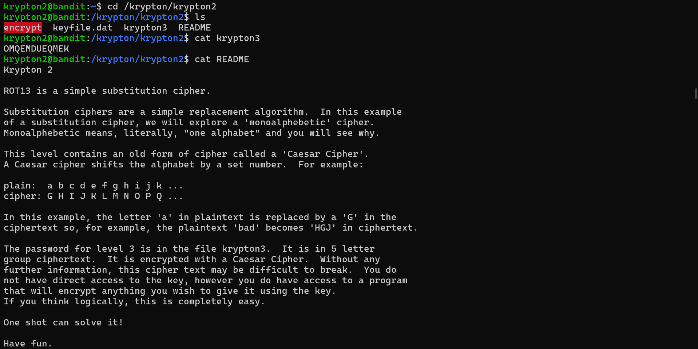

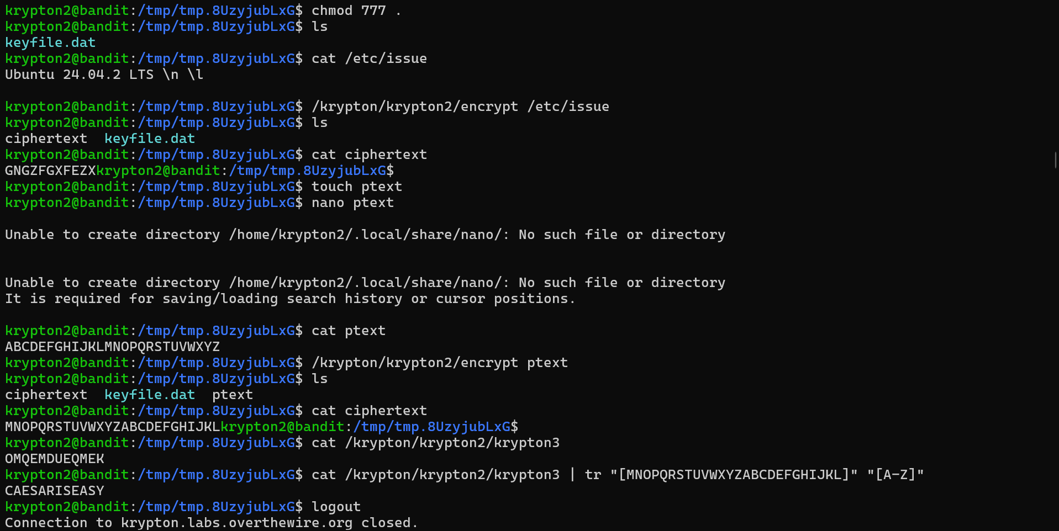

* Krypton Level 3 → Level 4

Step 1: Enter ssh -p 2231 [krypton3@krypton.labs.overthewire.org](mailto:krypton3@krypton.labs.overthewire.org)

Step 2: Enter the password found

Step 3: Read the instruction provided properly. Use the helpful commands cat found1 found 2 found 3 to encrypt the code

Step 4: Enter the commands to get the password for next level.

Pw found : BRUTE

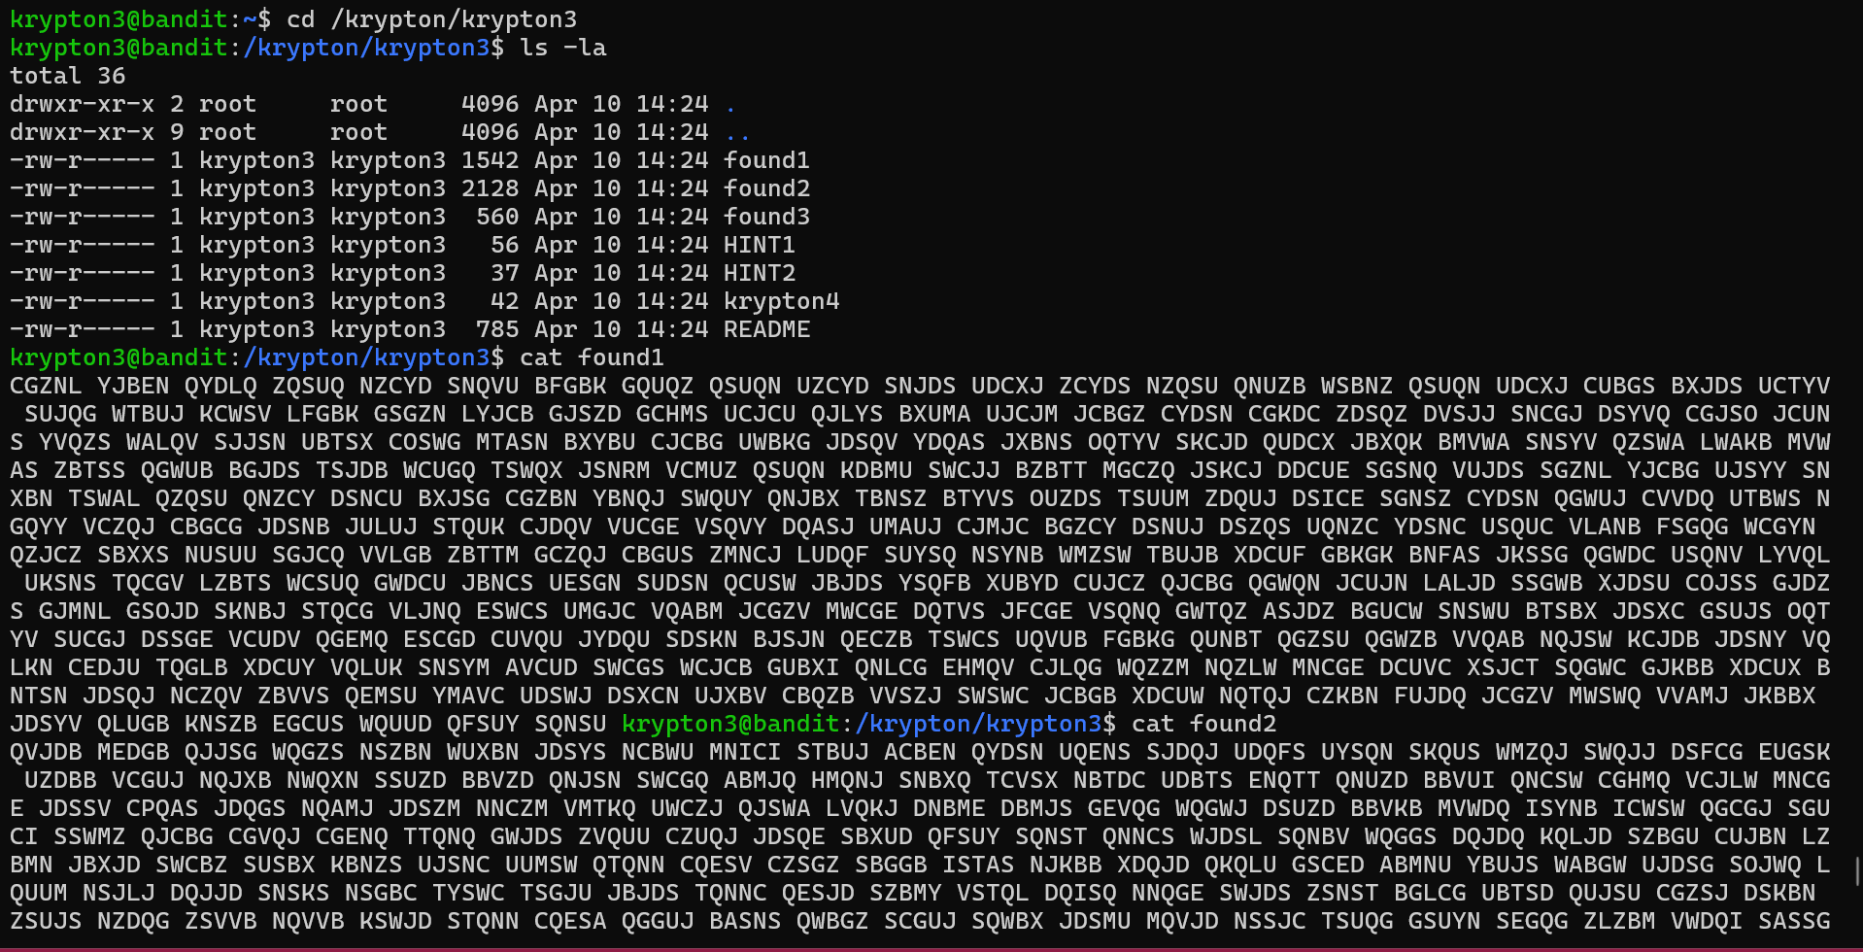



* Krypton Level 4 → Level 5

Step 1: Enter ssh -p 2231 [krypton4@krypton.labs.overthewire.org](mailto:krypton4@krypton.labs.overthewire.org)

Step 2: Enter the password found

Step 3: Read the instruction provided properly. Convert the plaintext to ciphertext. Make use of hints provided in it.

Step 4: Enter the commands

Pw:CLEARTEXT

Logic: Use google to solve the ciphertext and also commands .

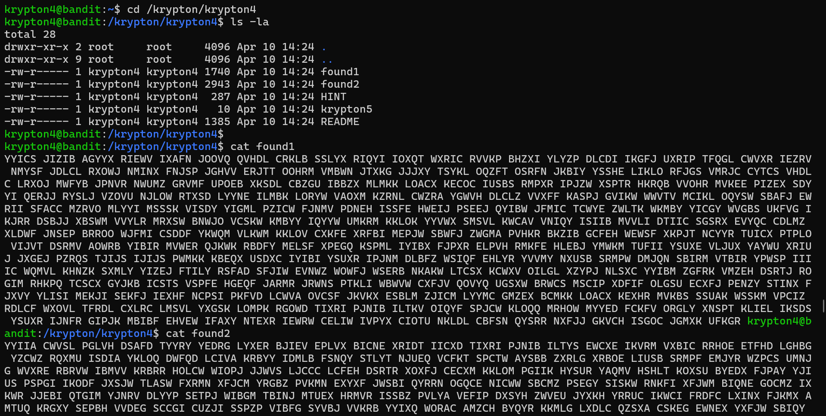

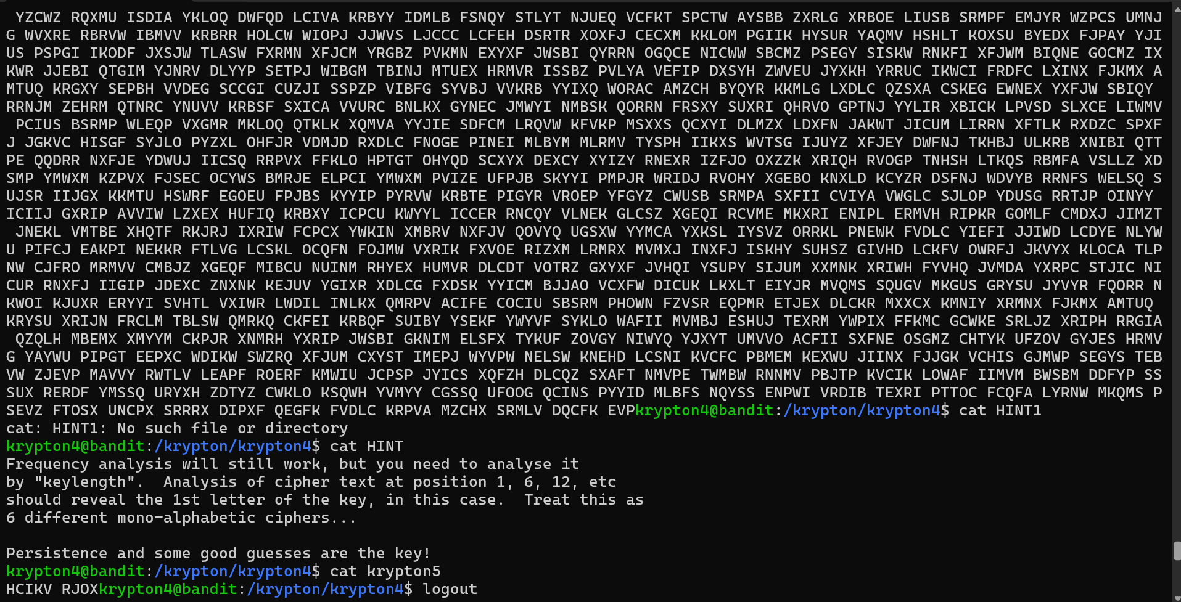

* Krypton Level 5 → Level 6

Step 1: Enter ssh -p 2231 [krypton5@krypton.labs.overthewire.org](mailto:krypton5@krypton.labs.overthewire.org)

Step 2: Enter the password found

Step 3: Read the instruction provided properly. Make use of hints provided in it.

Step 4: polyalphabetic cipher

PW found: RANDOM

Logic: Used the encrypt code url to find the plaintext.

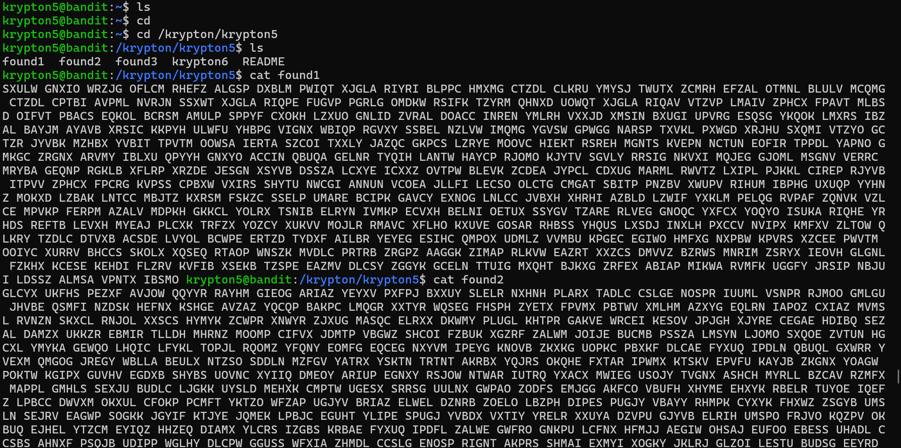

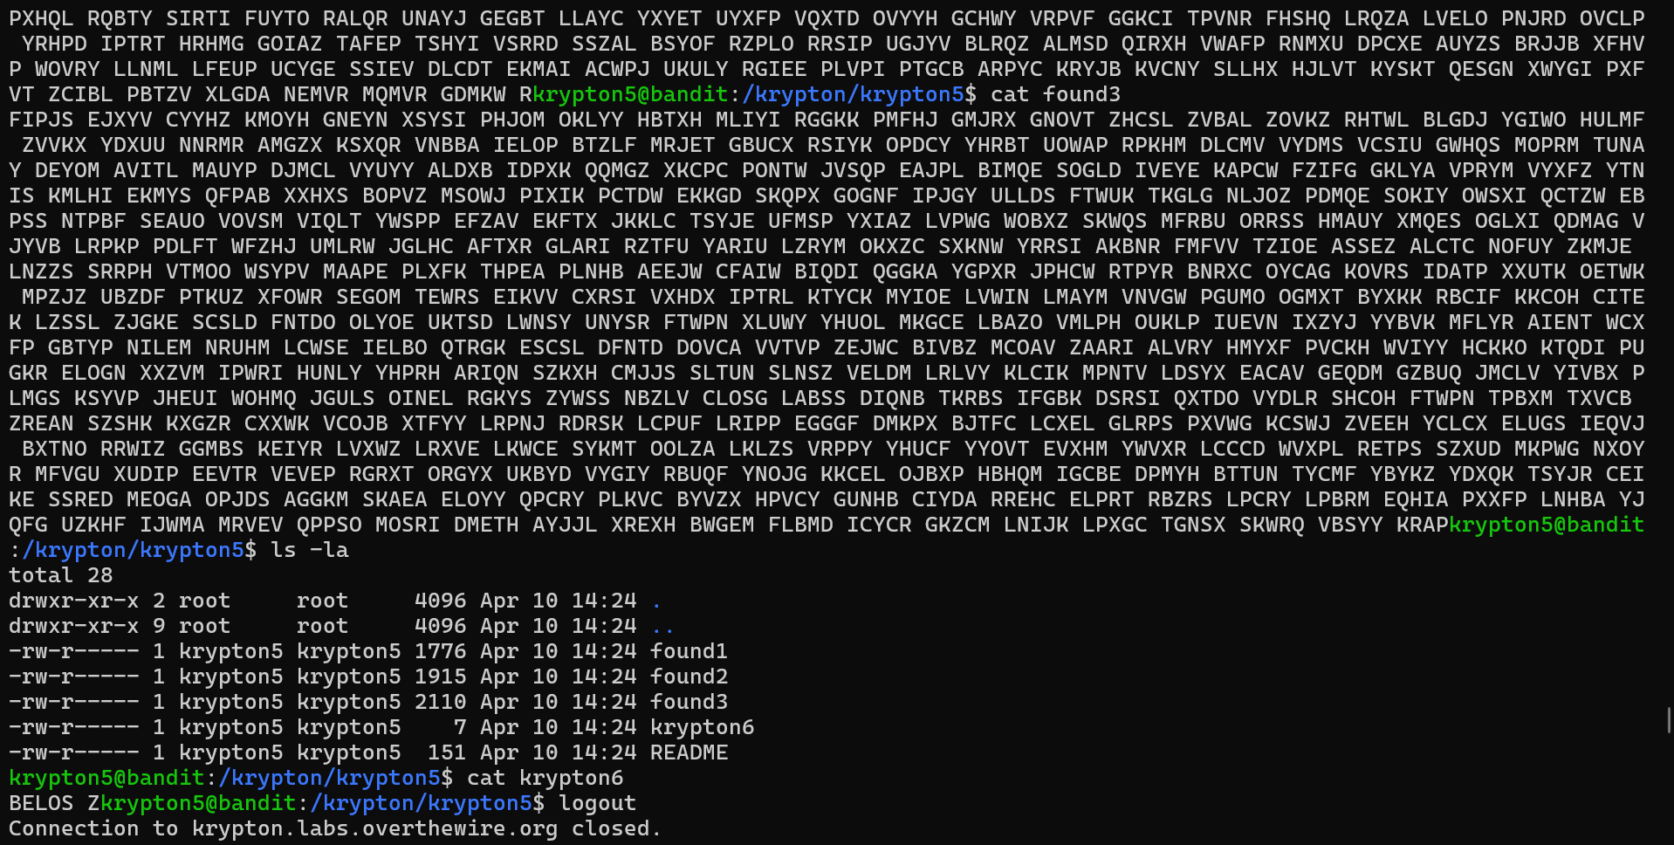

* Krypton Level 6 → Level 7

Step 1: Enter ssh -p 2231 [krypton6@krypton.labs.overthewire.org](mailto:krypton6@krypton.labs.overthewire.org)

Step 2: Enter the password found

Step 3: Read the instruction provided properly. Convert the plaintext to ciphertext. Make use of hints provided in it.

Step 4: Enter the commands needed

Pw found : LFSRISNOTRANDOM

Logic : Solve the krypton labs using commands

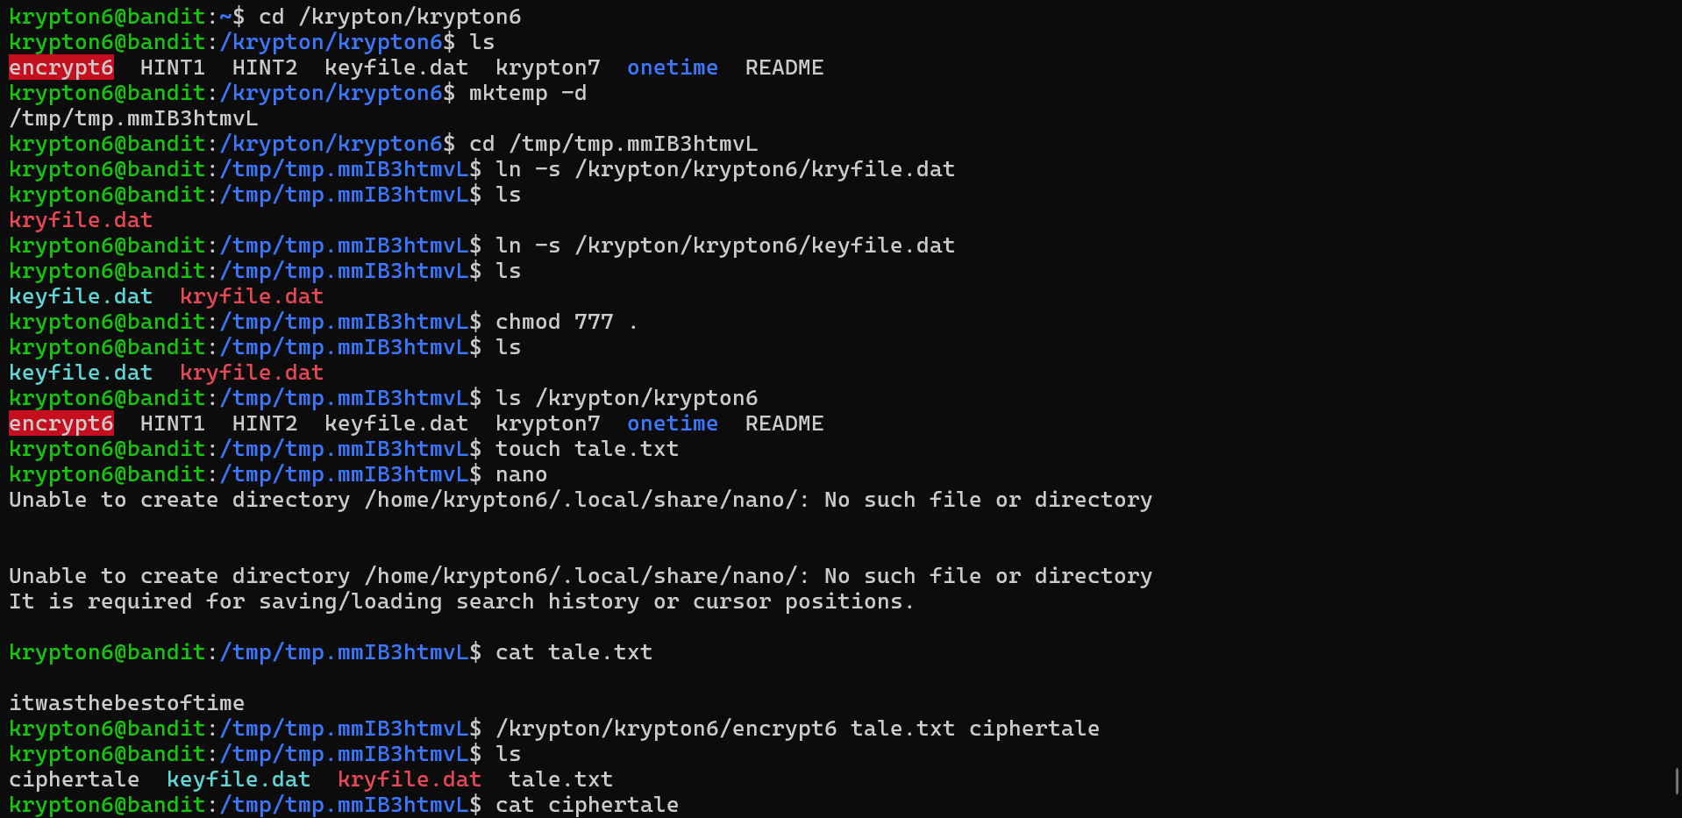

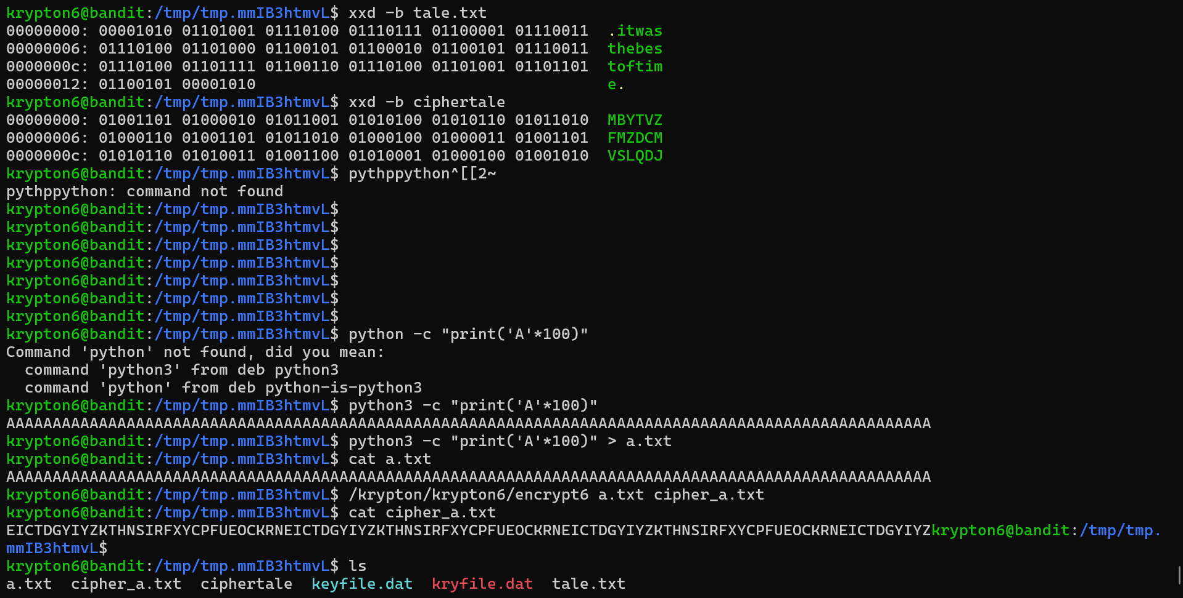

1. **NATAS** – https://overthewire.org/wargames/natas/

Tool: NATAS done on chrome

* **Natas Level 0 → Level 1**

**Step 1: Open** [**http://natas0.natas.labs.overthewire.org**](http://natas0.natas.labs.overthewire.org)

**Step 2: View page source to find the password.**

**Password Found: gtVrDuiDfck831PqWsLEZy5gyDz1clto**

**Logic: Password is inside HTML comments.**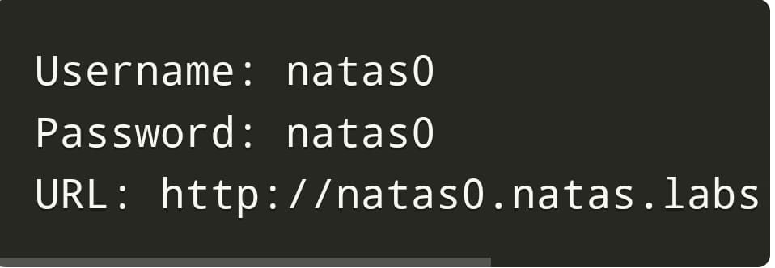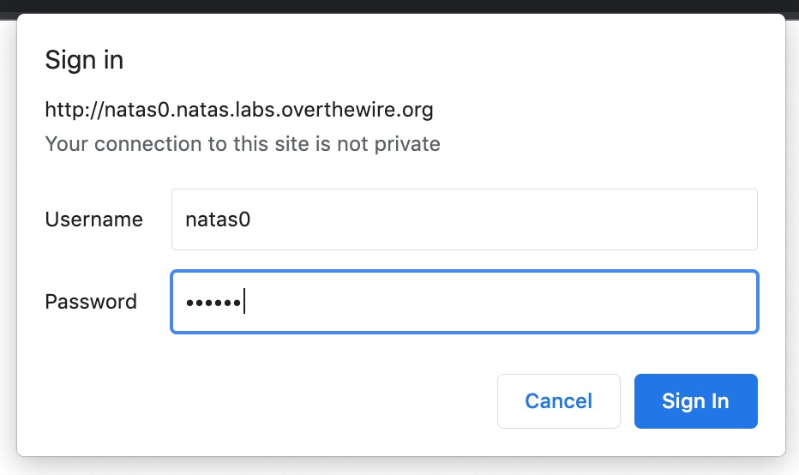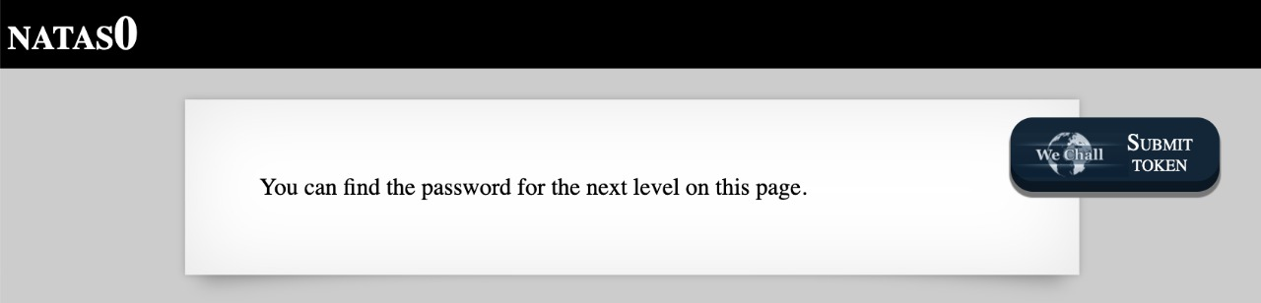

* **NATAS Level 1 → Level 2**

**Step 1: Open** [**http://natas1.natas.labs.overthewire.org**](http://natas1.natas.labs.overthewire.org)

**Step 2: View page source, find password hidden.**

**Password Found: ZluruAthQk7Q2MqmDeTiUij2ZvWy2mBi**

**Logic: Password hidden in comments again.**

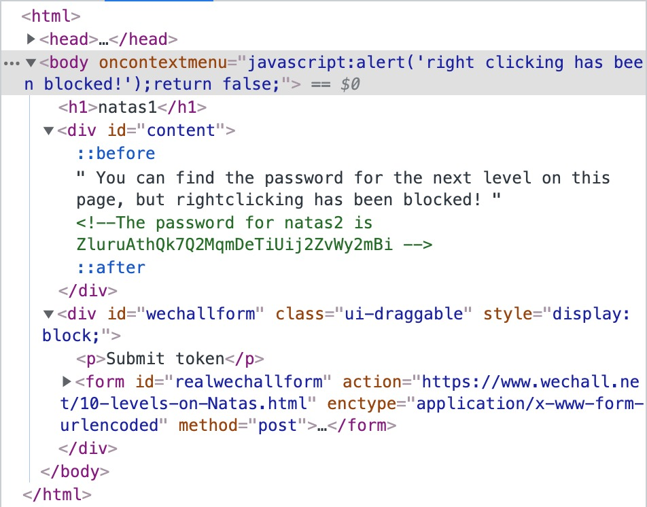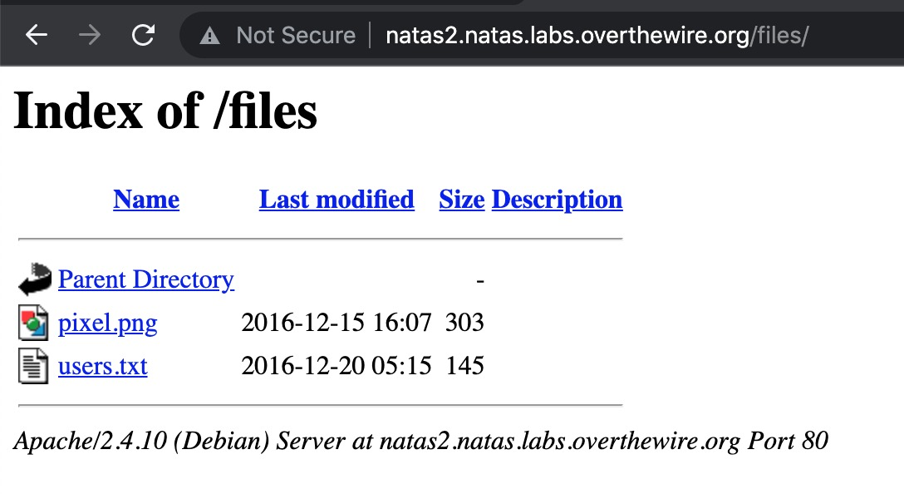

* **NATAS Level 2 → Level 3**

**Step 1: Open** [**http://natas2.natas.labs.overthewire.org**](http://natas2.natas.labs.overthewire.org)

**Step 2: Check /files/ directory using robots.txt.**

**Password Found: sJIJNW6ucpu6HPZ1ZAchaDtwd7oGrD14**

**Logic : Access hidden folders from robots.txt.** 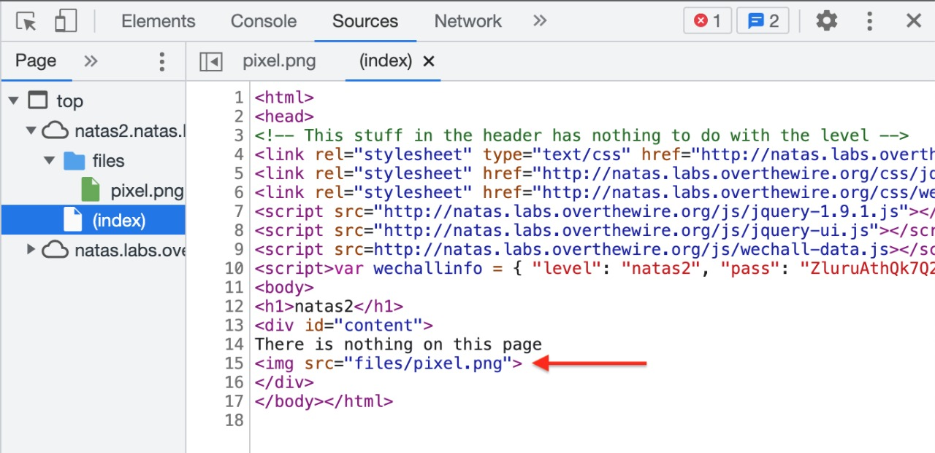 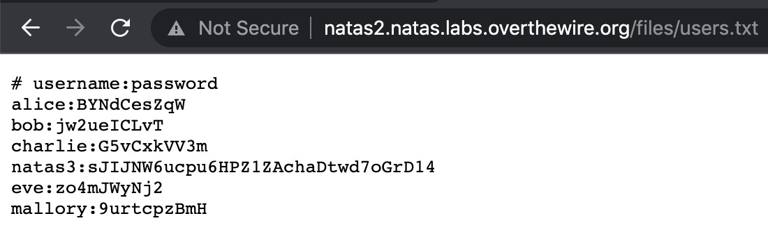

* **NATAS Level 3 → Level 4**

**Step 1:** **Open** [**http://natas3.natas.labs.overthewire.org**](http://natas3.natas.labs.overthewire.org)

**Step 2: Find hidden directory link from the page source.**

**Password Found : Z9tkRkWmpt9Qr7XrR5jWRkgOU901swEZ**

**Logic: Analyze links and hidden directories.**

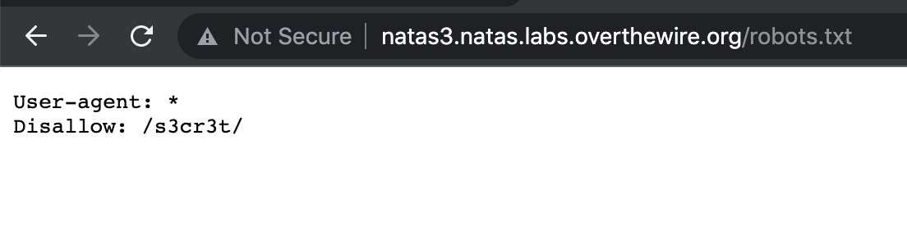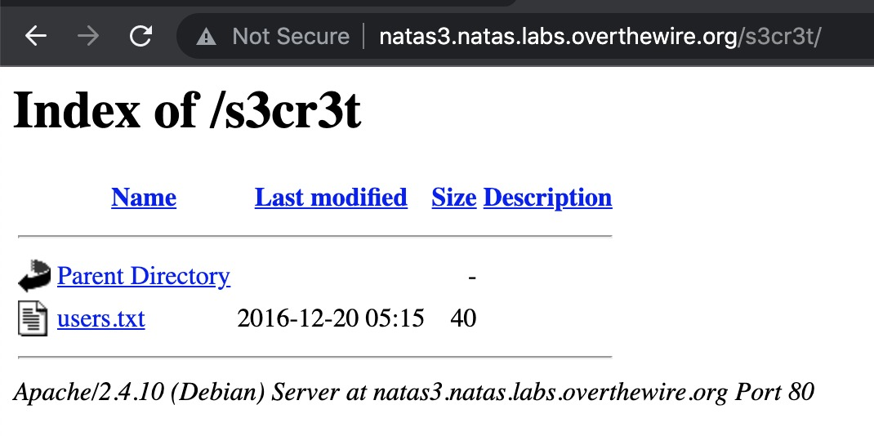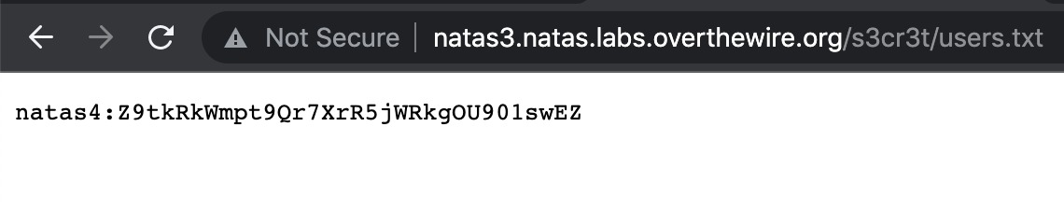

* **NATAS Level 4 → Level 5**

**Step 1** **Open** [**http://natas4.natas.labs.overthewire.org**](http://natas4.natas.labs.overthewire.org)**.**

**Step 2: Modify HTTP Referer header.**

**Password Found: iX6IOfmpN7AYOQGPwtn3fXpbaJVJcHfq**

**Logic: Change referer to expected page.**

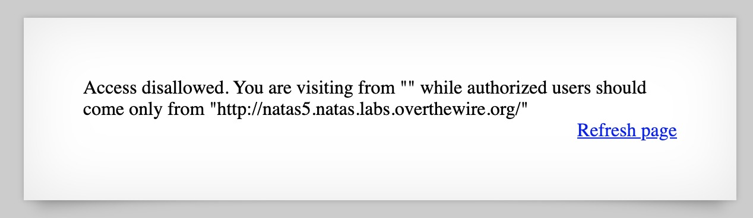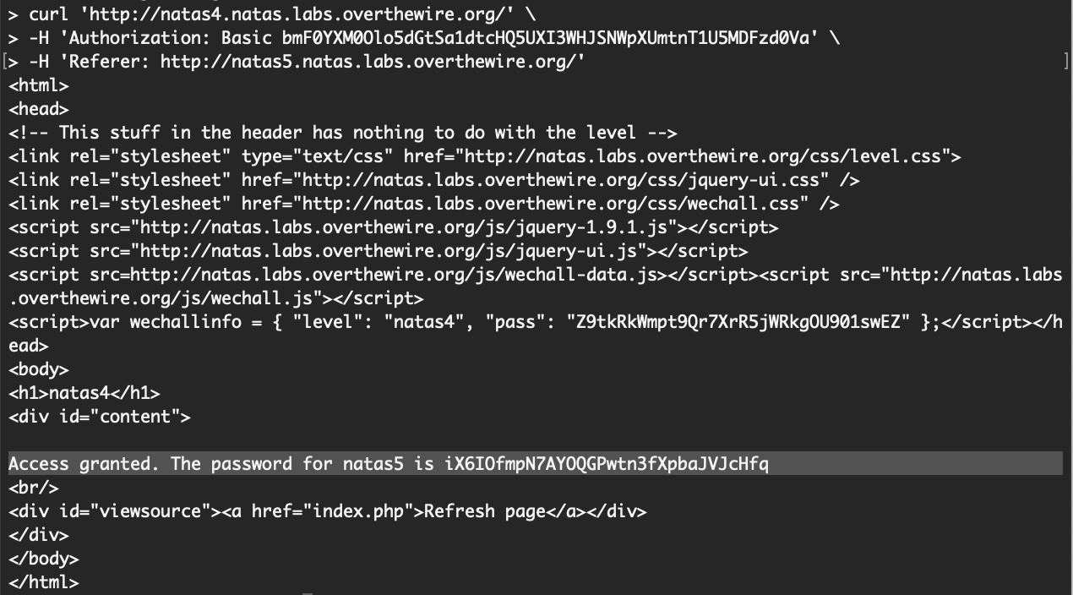

* **NATAS Level 5 → Level 6**

**Step 1: Open** [**http://natas5.natas.labs.overthewire.org**](http://natas5.natas.labs.overthewire.org)

**Step 2: Enter the password found**

**Password Found: aGoY4q2Dc6MgDq4oL4YtoKtyAg9PeHa1**

**Logic: Modify cookie values.**

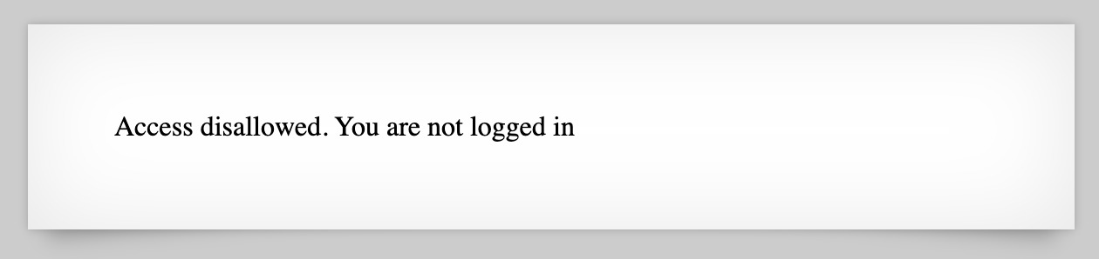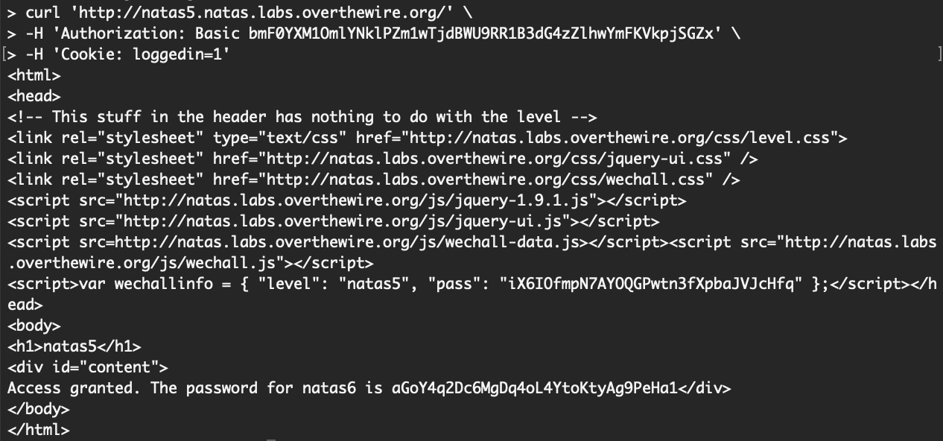

* **NATAS Level 6 → Level 7**

**Step 1: Open** [**http://natas6.natas.labs.overthewire.org**](http://natas6.natas.labs.overthewire.org)

**Step 2: Find and use the secret stored in a file.**

**Password Found: 7z3hEENjQtflzgnT29q7wAvMNfZdh0i9**

**Logic: Read secret from web server file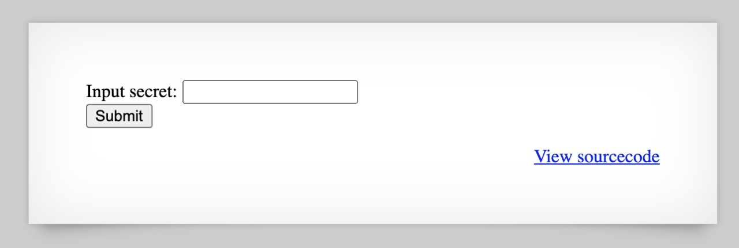.**

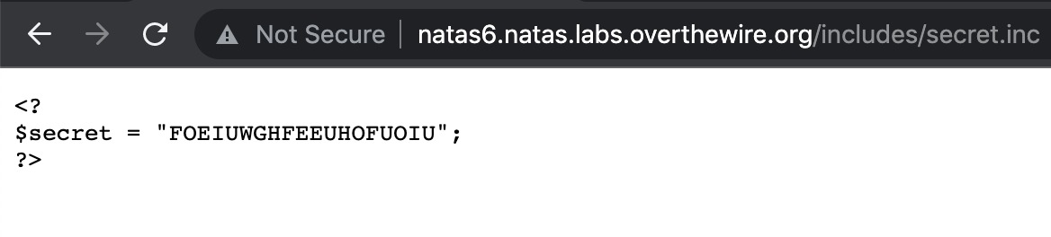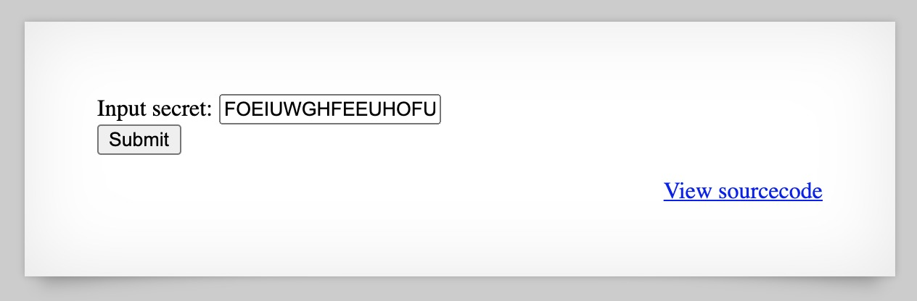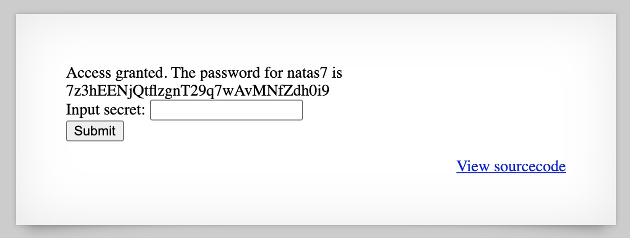

* **NATAS Level 7 → Level 8**

**Step 1: Open** [**http://natas7.natas.labs.overthewire.org**](http://natas7.natas.labs.overthewire.org)

**Step 2: URL parameter manipulation (page name).**

**Password Found: DBfUBfqQG69KvJvJ1iAbMoIpwSNQ9bWe**

**Logic: Bypass page restrictions using URLs.**

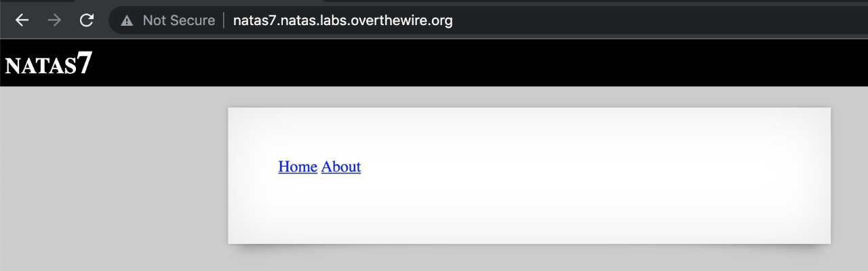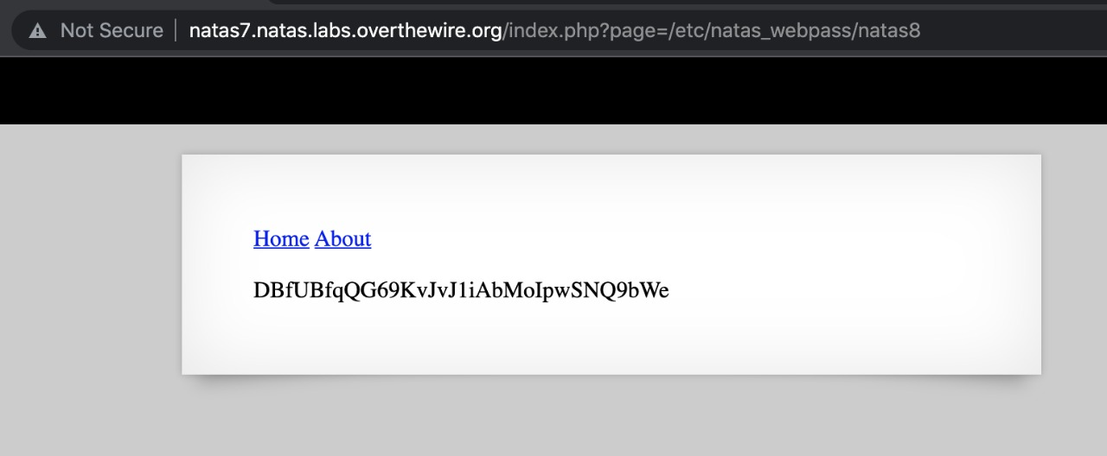

* **NATAS Level 8 → Level 9**

**Step 1: Open** [**http://natas8.natas.labs.overthewire.org**](http://natas8.natas.labs.overthewire.org)

**Step 2: Analyze PHP code, decrypt using XOR or similar.**

**Password Found: W0mMhUcRRnG8dcghE4qvk3JA9lGt8nDl**

**Logic: Understand PHP obfuscation and reverse.**

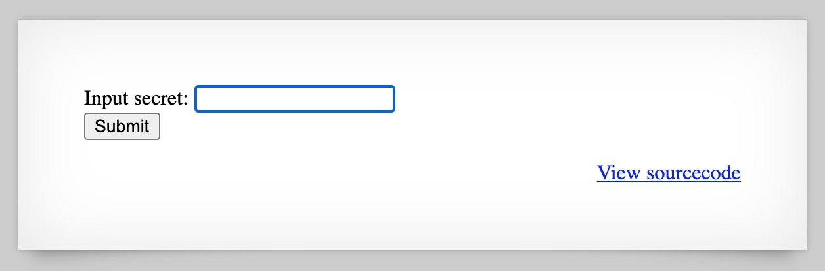

* **NATAS Level 9 → Level 10**

**Step 1: Open** [**http://natas9.natas.labs.overthewire.org**](http://natas9.natas.labs.overthewire.org)

**Step 2: Command injection vulnerability - enter ; cat /etc/natas_webpass/natas10**

**Password Found: nOpp1igQAkUzaI1GUUjzn1bFVj7xCNzu**

**Logic: Exploit command injection.**

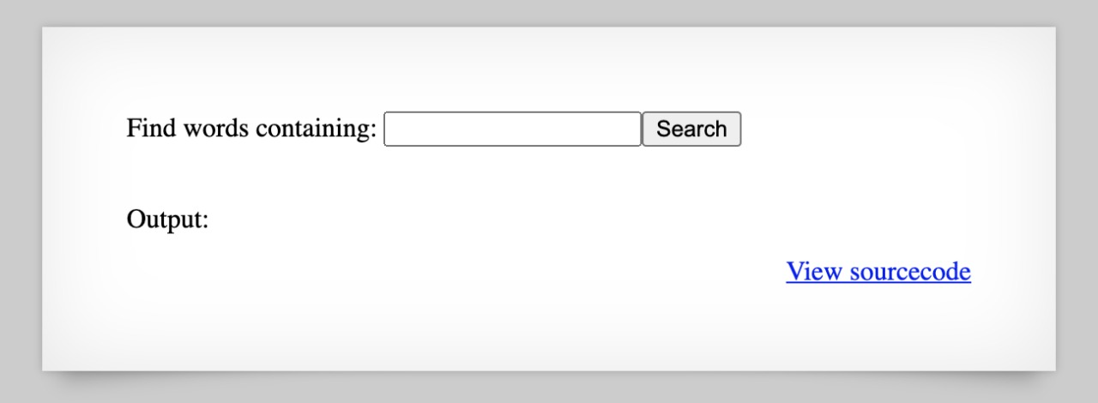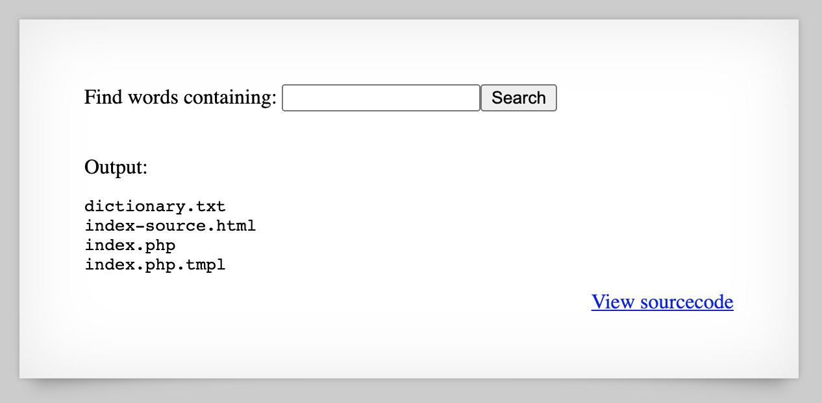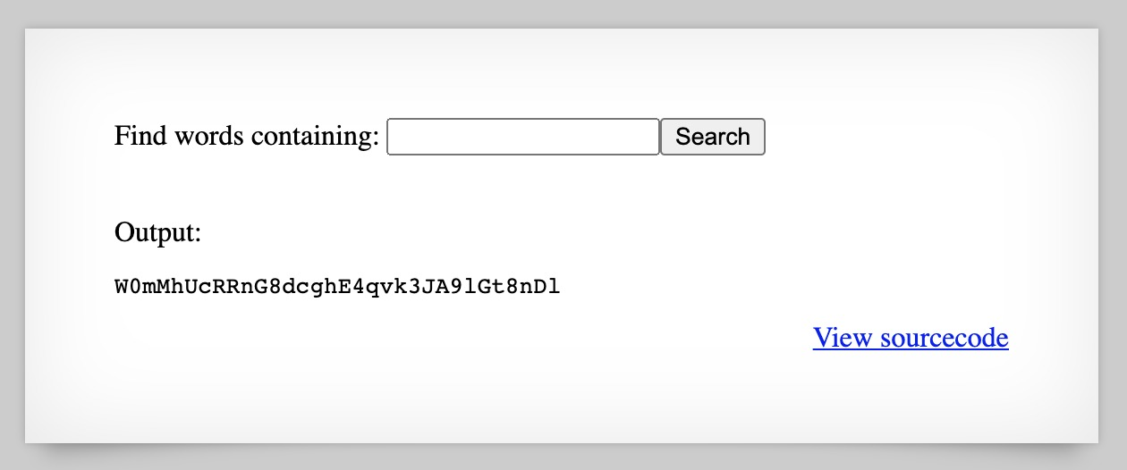

* **NATAS Level 10 → Level 11**

**Step 1: Open** [**http://natas10.natas.labs.overthewire.org**](http://natas10.natas.labs.overthewire.org)

**Step 2: Filter bypass for command injection (use $(cat filename)).**

**Password Found: U82q5TCMMQ9xuFoI3dYX61s7OZD9JKoK**

**Logic: Bypass filters by using alternate syntax.**

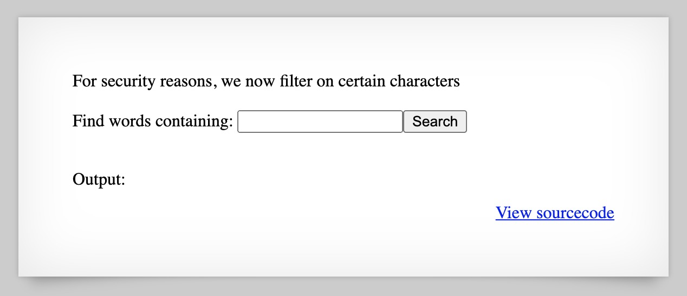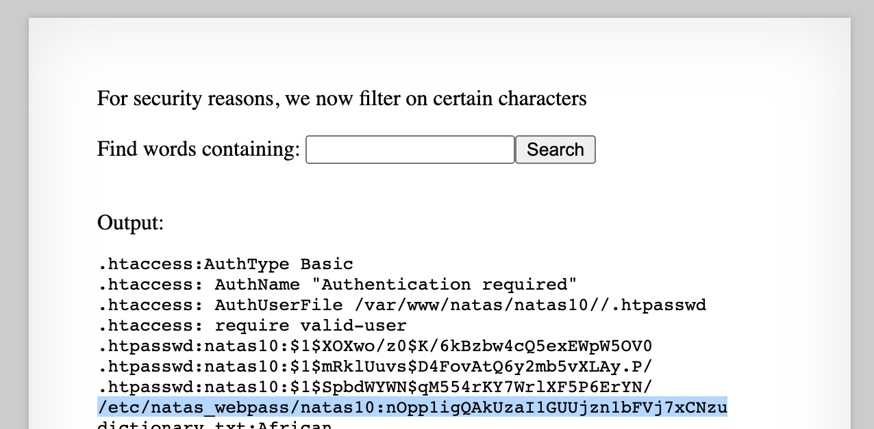

* **NATAS Level 11 → Level 12**

**Step 1: Open** [**http://natas11.natas.labs.overthewire.org**](http://natas11.natas.labs.overthewire.org)

**Step 2: Modify cookie and decode XOR-encrypted cookies.**

**Password Found : EDXp0pS26wLKHZy1rDBPUZk0RKfLGIR3**

**Logic: Cookie manipulation and decryption.**

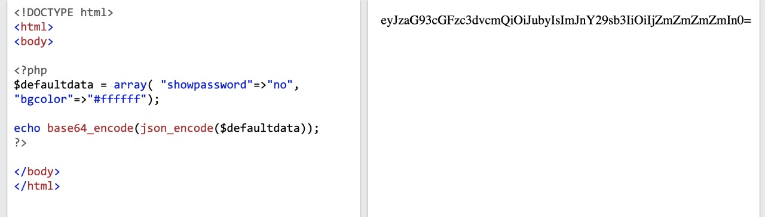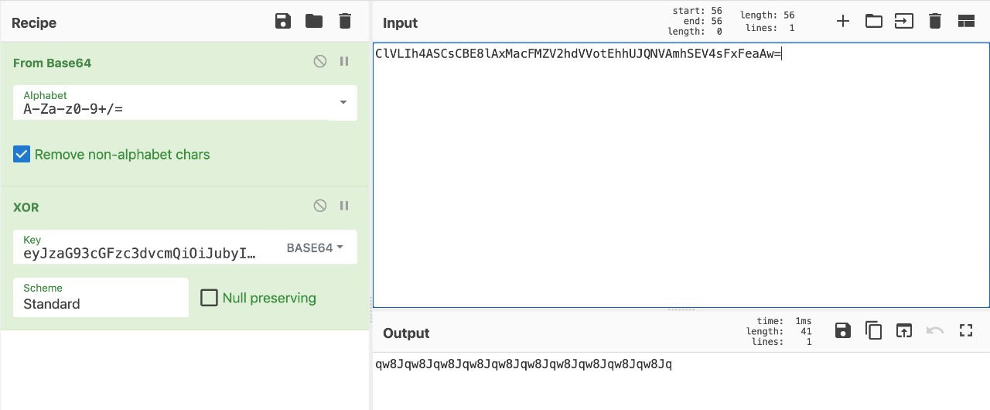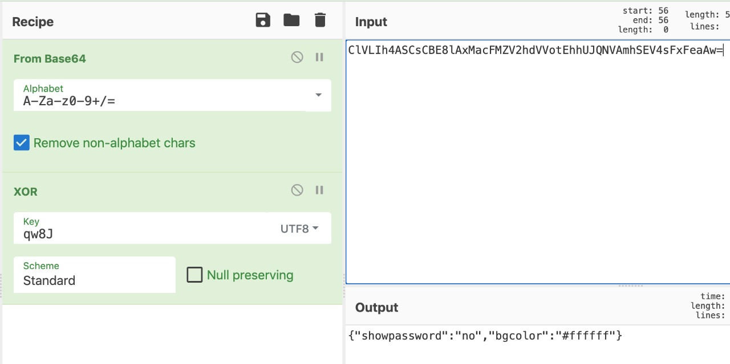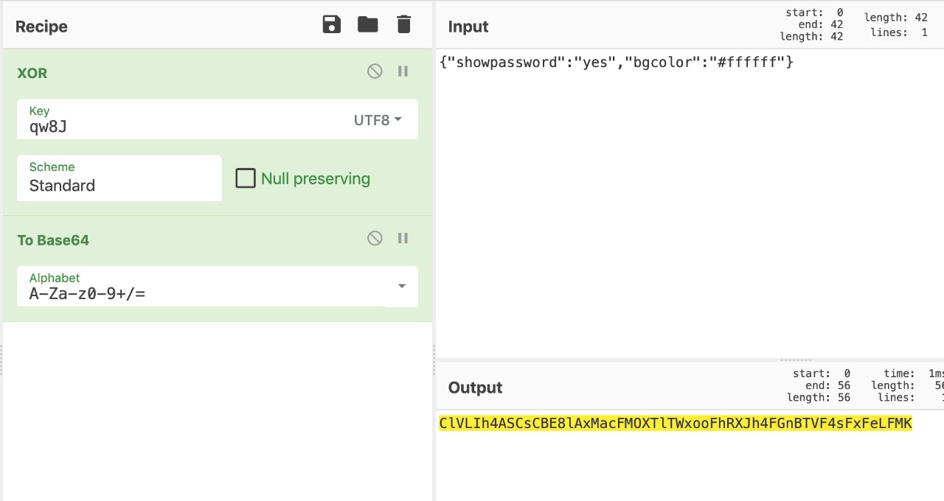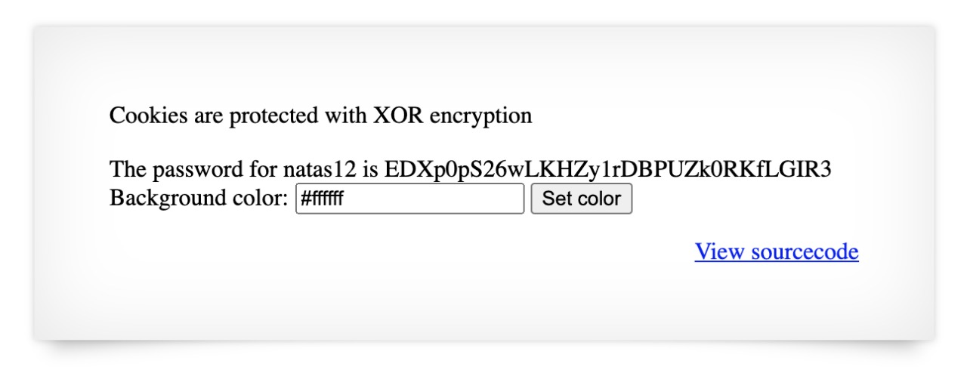

* **NATAS Level 12 → Level 13**

**Step 1: Open** [**http://natas12.natas.labs.overthewire.org**](http://natas12.natas.labs.overthewire.org)

**Step 2: Upload a PHP shell file (bypass file extension checks).**

**Password Found: jmLTY0qiPZBbaKc9341cqPQZBJv7MQbY**

**Logic: Exploit file upload vulnerability.**

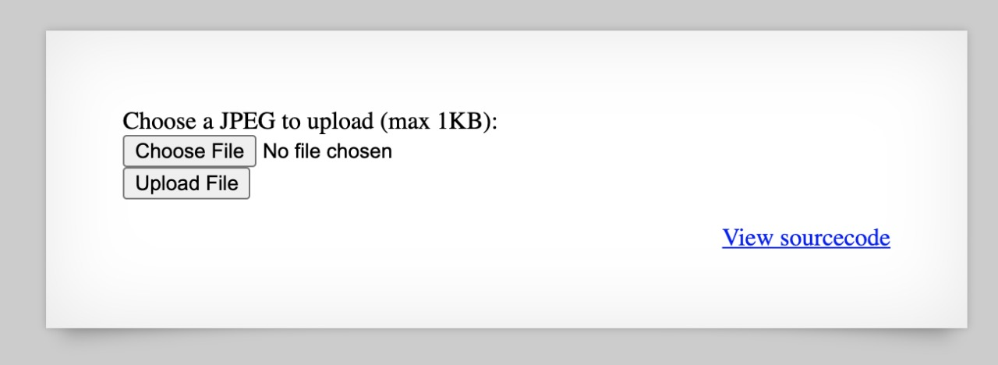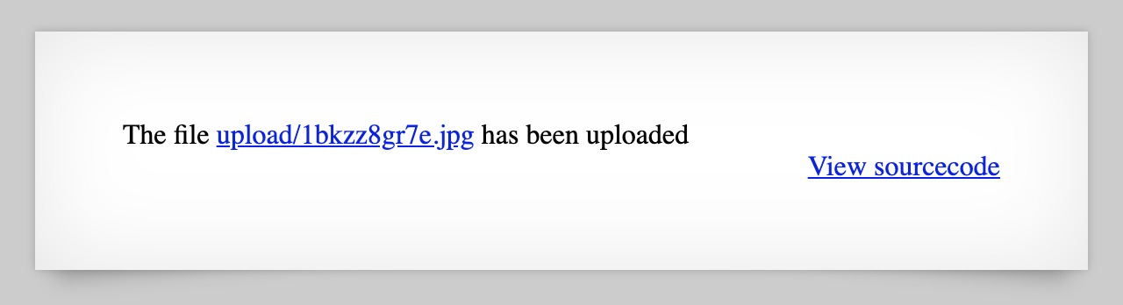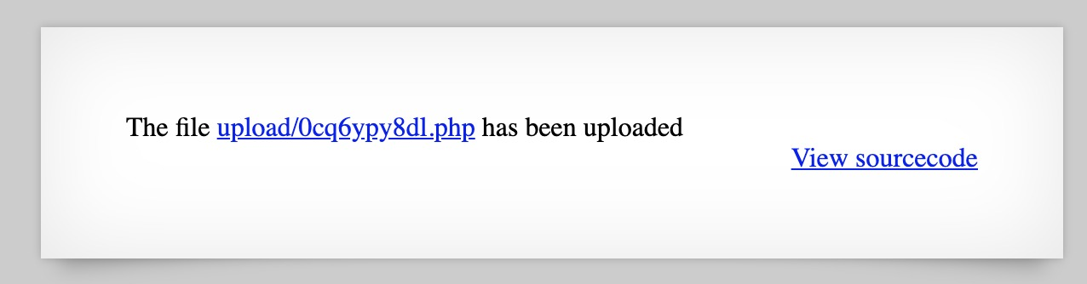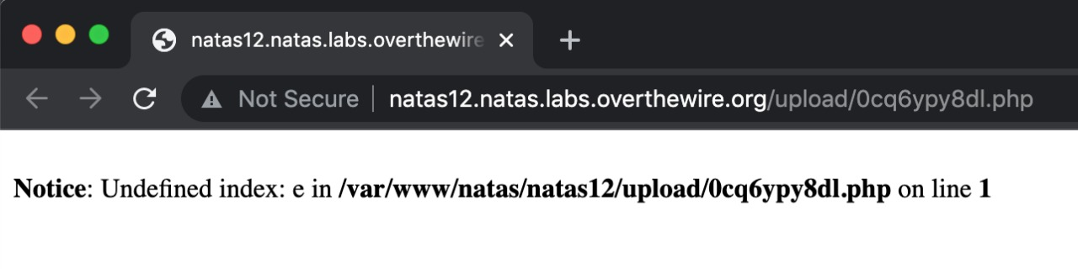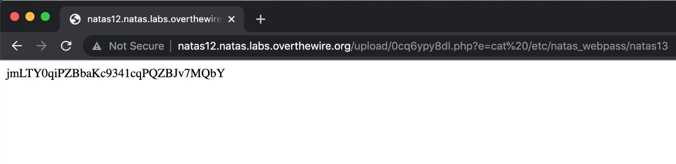

* **NATAS Level 13 → Level 14**

**Step 1: Open** [**http://natas13.natas.labs.overthewire.org**](http://natas13.natas.labs.overthewire.org)

**Step 2: Upload file with fake image header and PHP code inside.**

**Password Found: Lg96M10TdfaPyVBkJdjymbllQ5L6qdl1**

**Logic: Craft file to bypass content-type checking.**

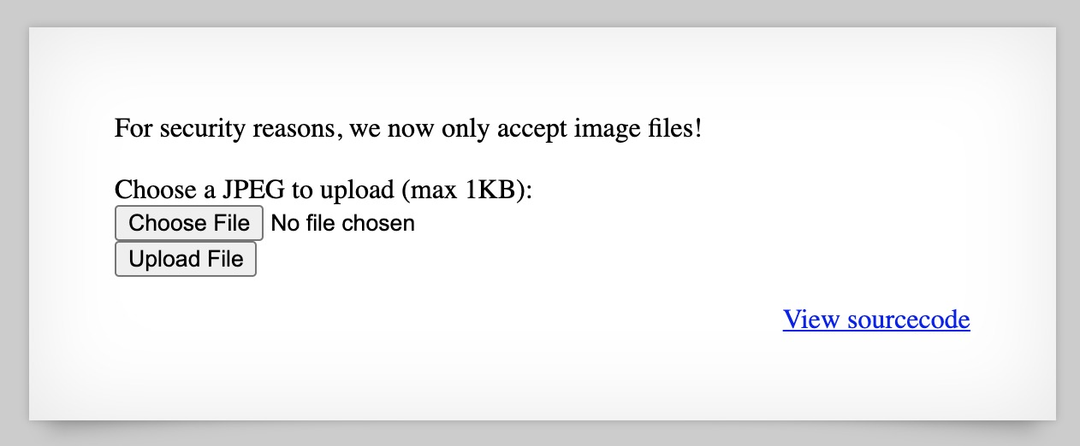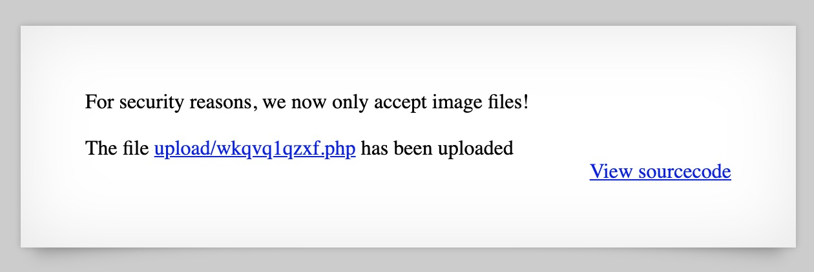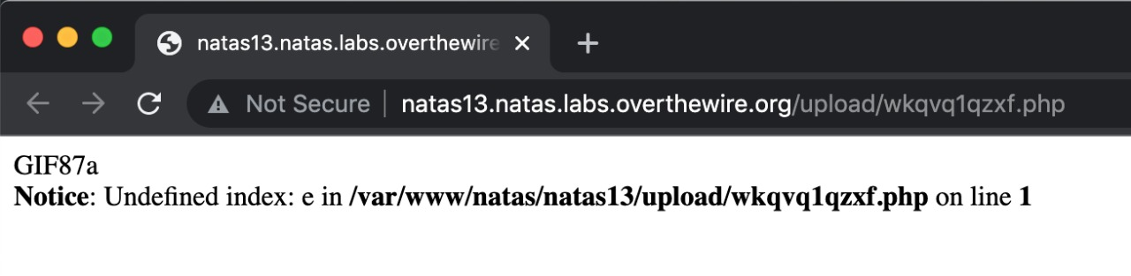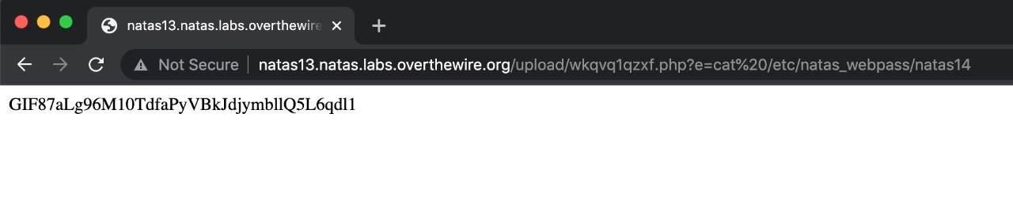

* **NATAS Level 14 → Level 15**

**Step 1: Open** [**http://natas14.natas.labs.overthewire.org**](http://natas14.natas.labs.overthewire.org)

**Step 2: SQL Injection (bypass login).**

**Password Found: AwWj0w5cvxrZiONgZ9J5stNVkmxdk39J**

**Logic: SQLi to gain authentication.**

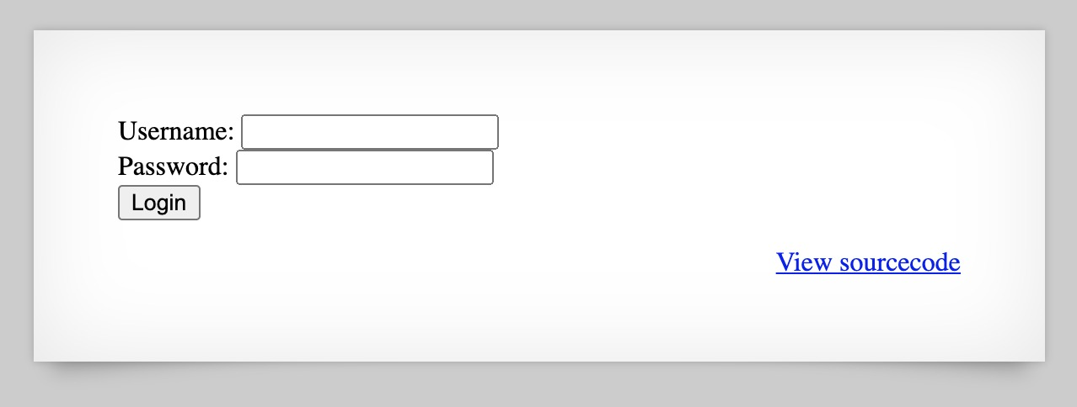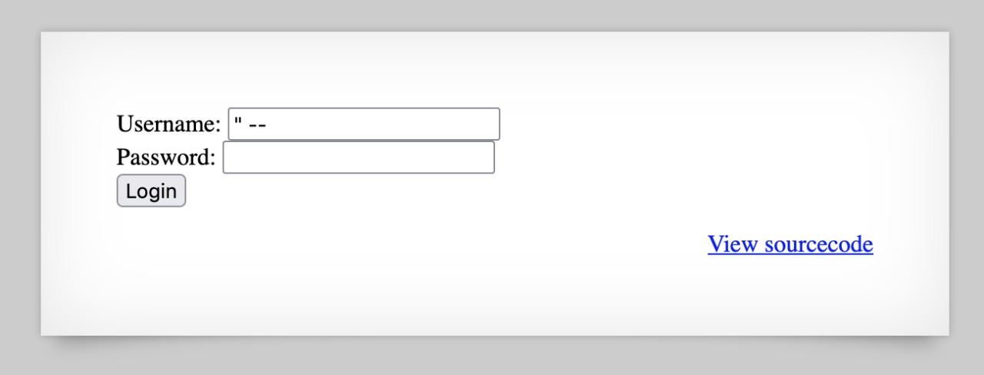

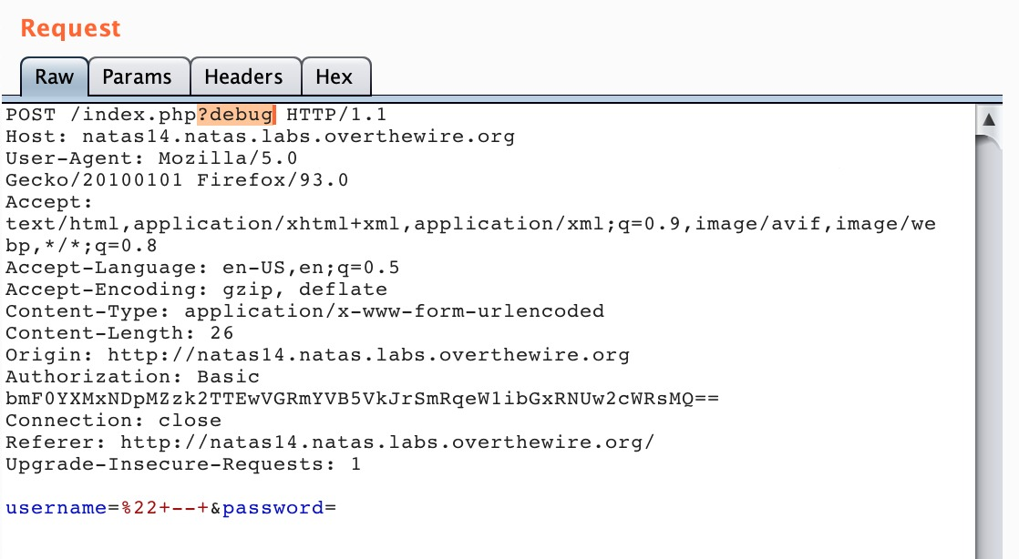

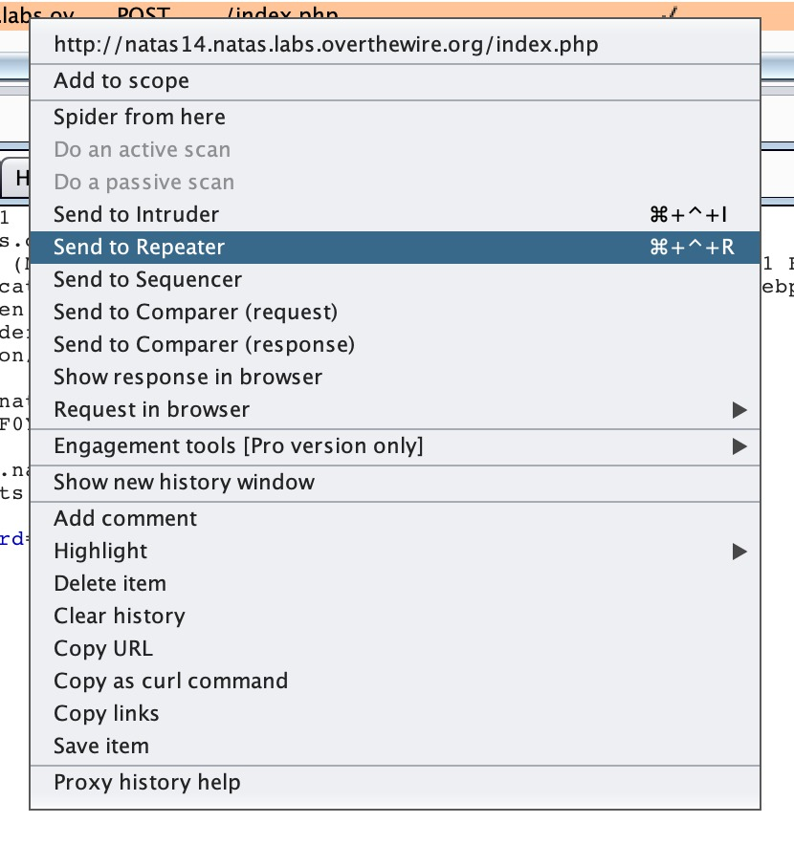



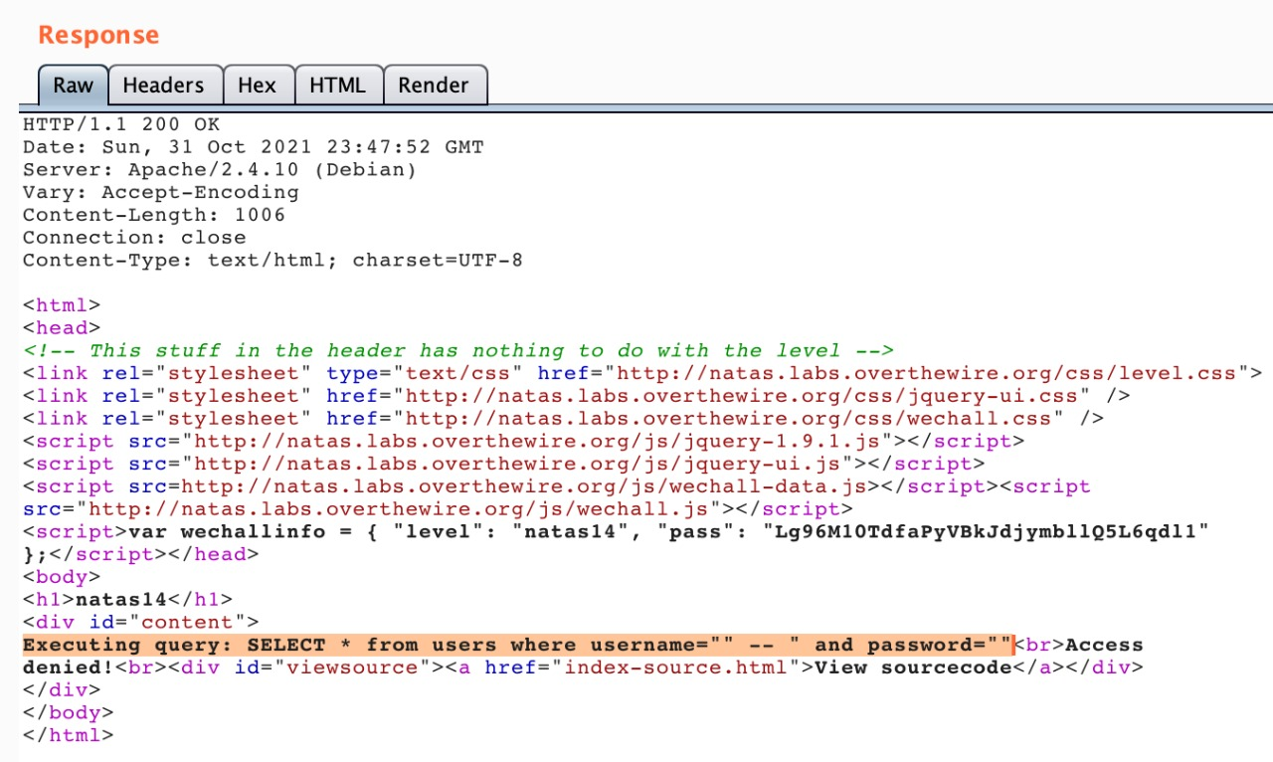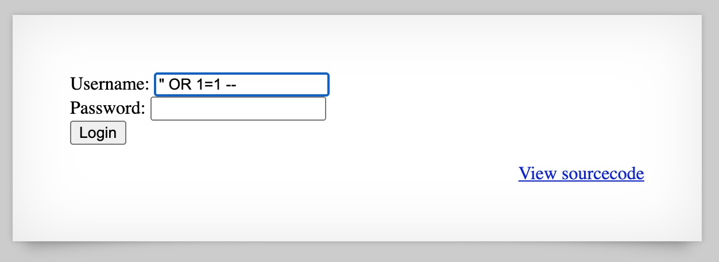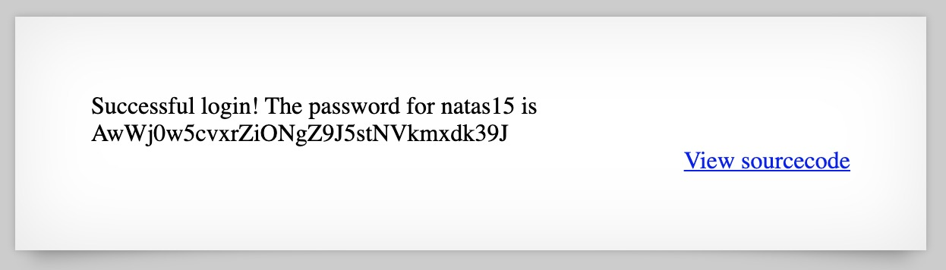

* **NATAS Level 15 → Level 16**

**Step 1: Open** [**http://natas15.natas.labs.overthewire.org**](http://natas15.natas.labs.overthewire.org)

**Step 2: Blind SQL Injection, extract password character by character.**

**Password Found: WaIHEacj63wnNIBROHeqi3p9t0m5nhmh**

**Logic: Infer data using blind SQL injection.**

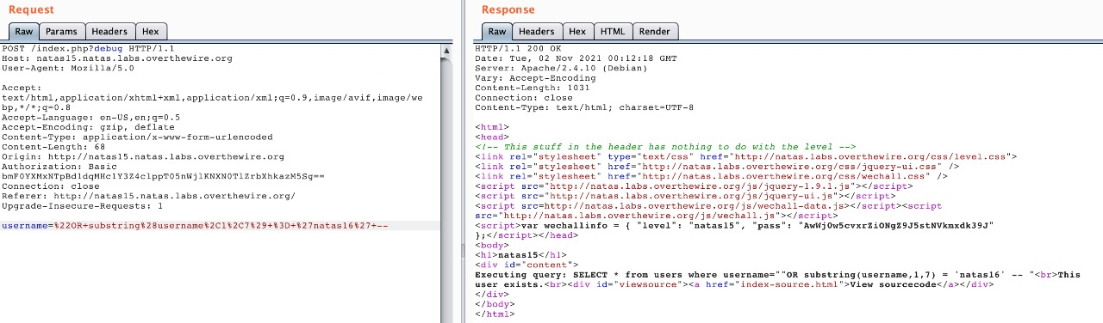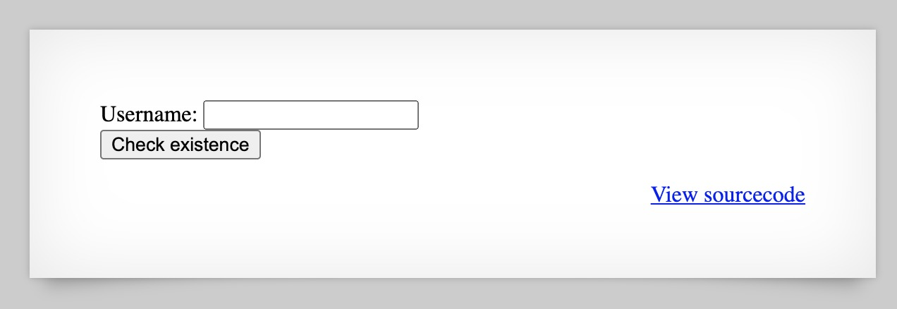

* **NATAS Level 16 → Level 17**

**Step 1: Open** [**http://natas16.natas.labs.overthewire.org**](http://natas16.natas.labs.overthewire.org)

**Step 2: Command Injection with whitespace filter bypass (use tabs, $IFS).**

**Password Found:** **8Ps3H0GWbn5rd9S7GmAdgQNdkhPkq9cw**

**Logic: Bypass whitespace filtering in command execution.**

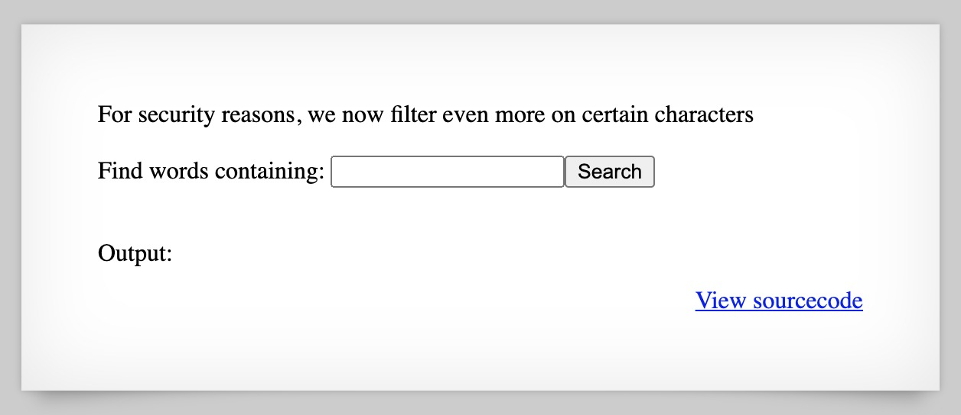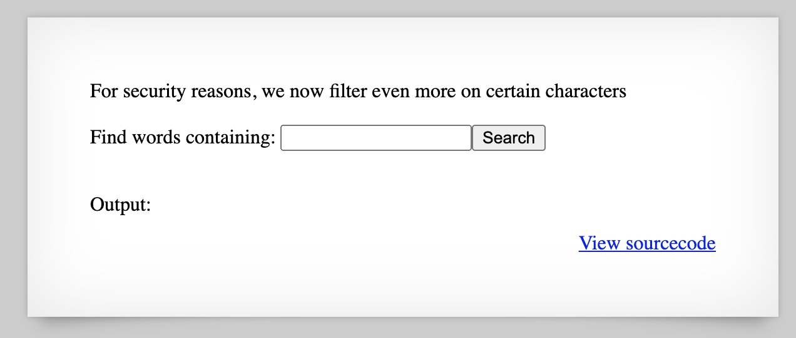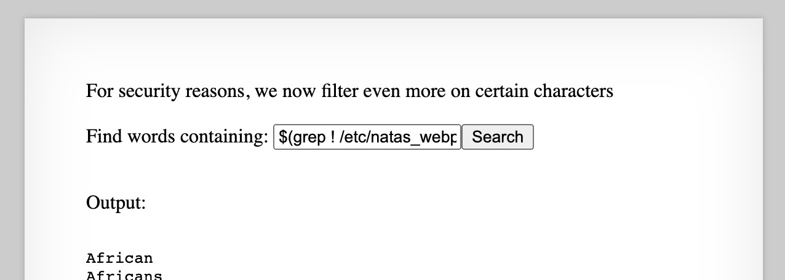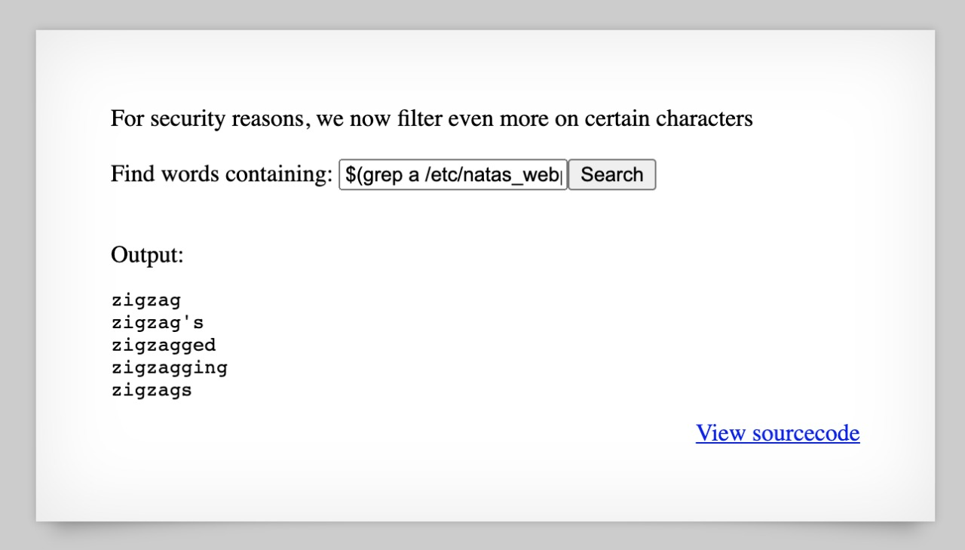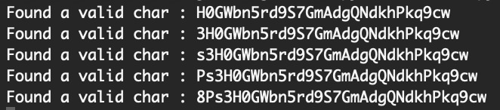

* **NATAS Level 17 → Level 18**

**Step 1: Open** [**http://natas17.natas.labs.overthewire.org**](http://natas17.natas.labs.overthewire.org)

**Step 2: Blind command injection (timing attack with sleep command).**

**Password Found: xvKIqDjy4OPv7wCRgDlmj0pFsCsDjhdP**

**Logic: Use time-based side channels to leak data.**

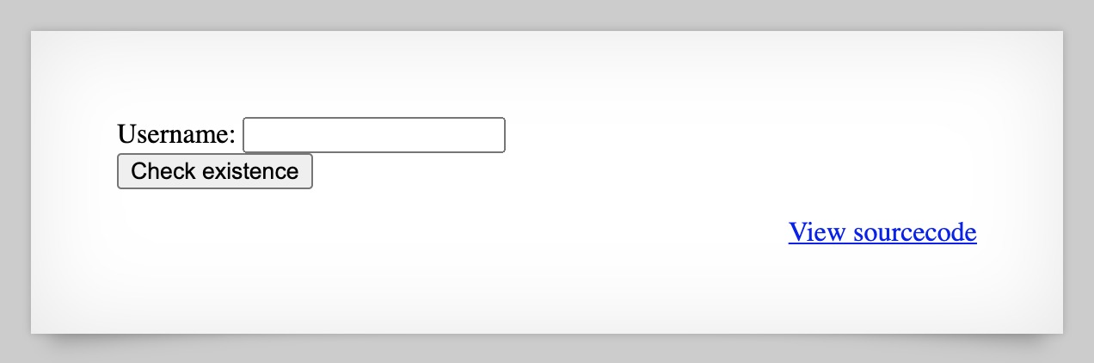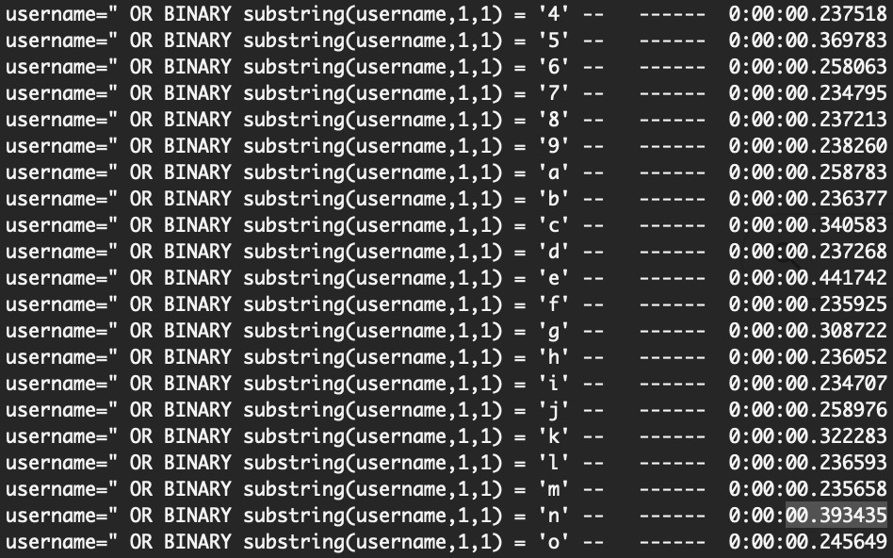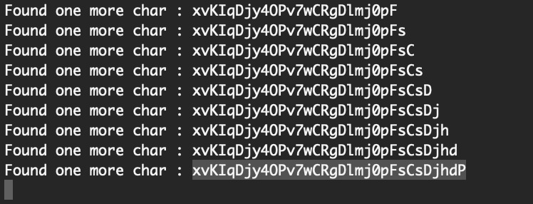

* **NATAS Level 18 → Level 19**

**Step 1: Open** [**http://natas18.natas.labs.overthewire.org**](http://natas18.natas.labs.overthewire.org)

**Step 2: Session ID brute-forcing.**

**Password Found: 4IwIrekcuZlA9OsjOkoUtwU6lhokCPYs**

**Logic: Find correct session ID among many.**

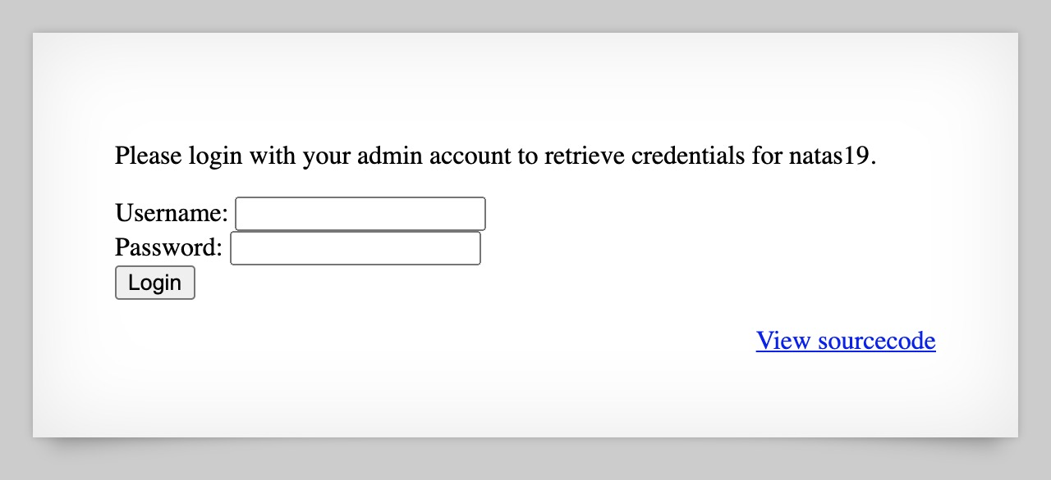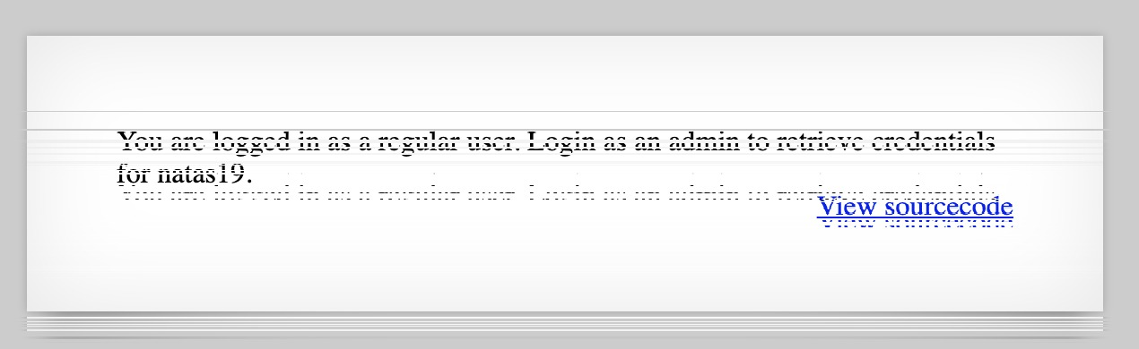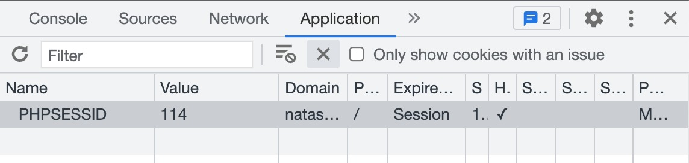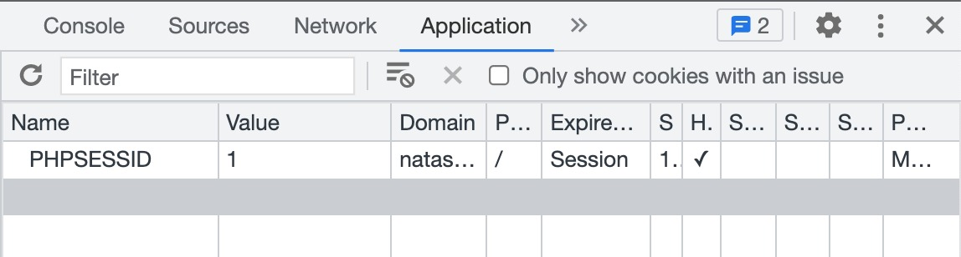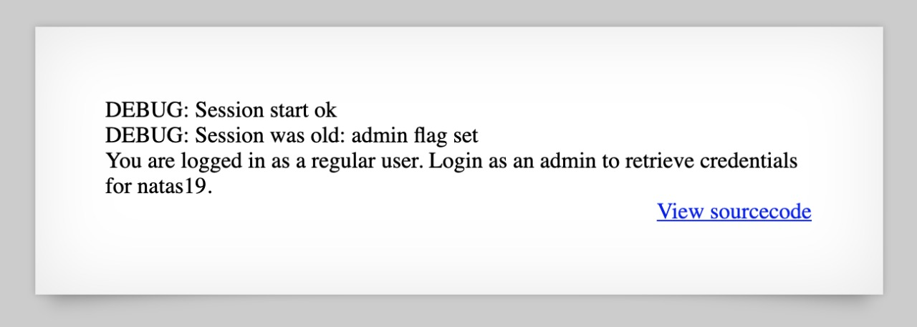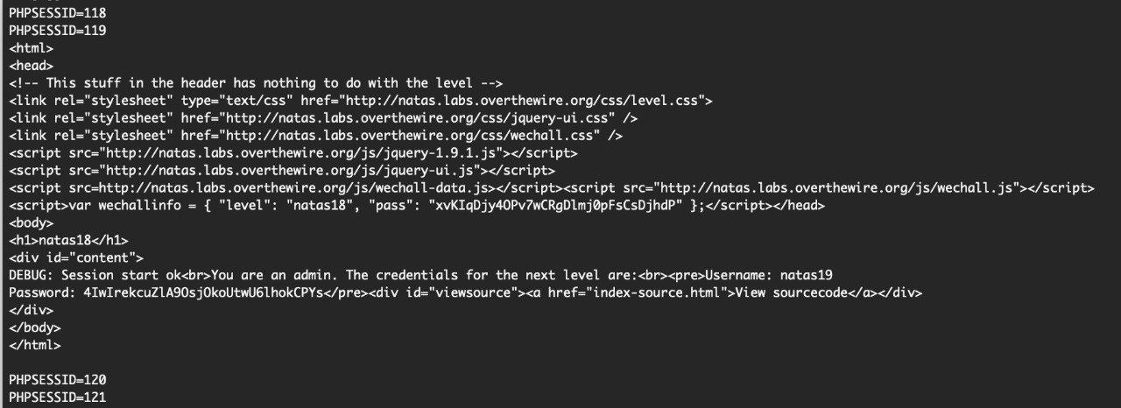

* **NATAS Level 19 → Level 20**

**Step 1: Open** [**http://natas19.natas.labs.overthewire.org**](http://natas19.natas.labs.overthewire.org)

**Step 2: Understand the encoding of session IDs.**

**Password Found:** **eofm3Wsshxc5bwtVnEuGIlr7ivb9KABF**

**Logic: Decode and brute force**

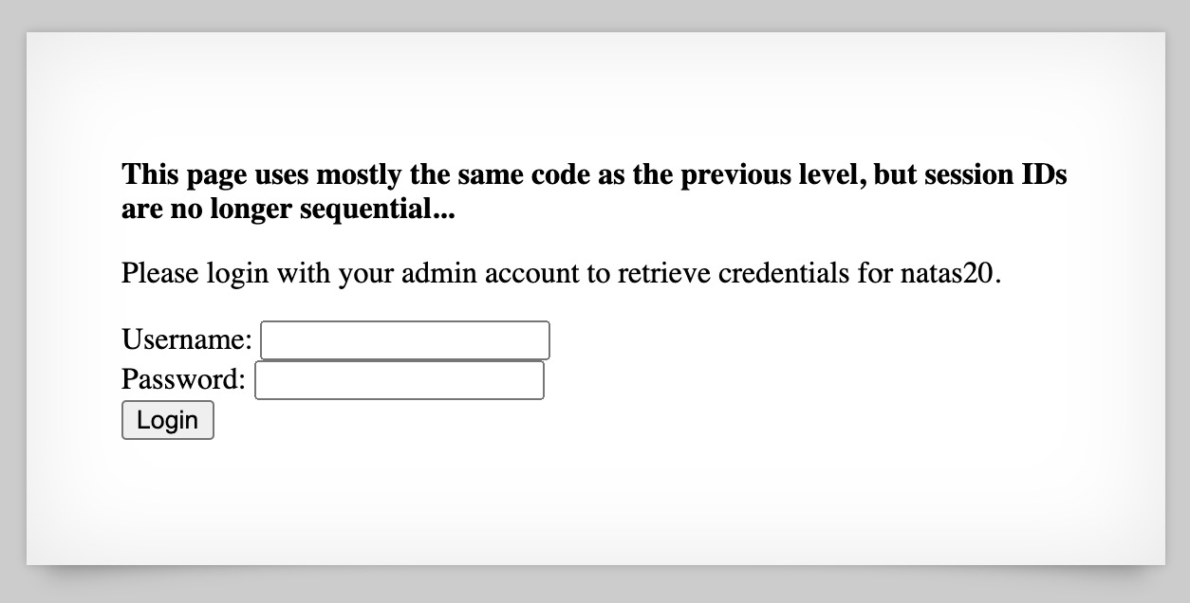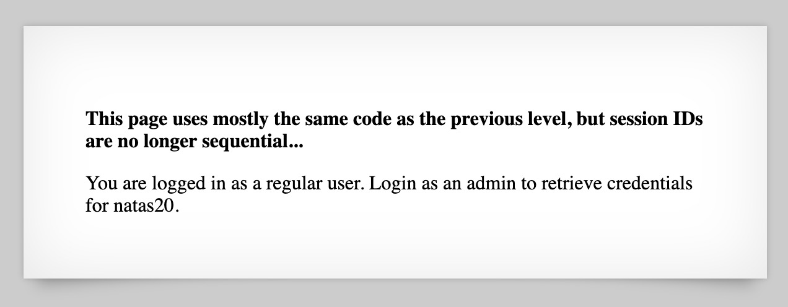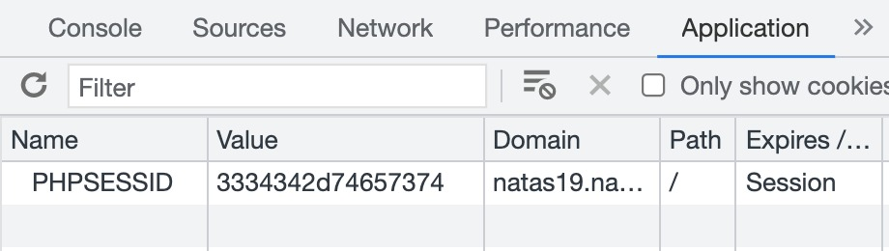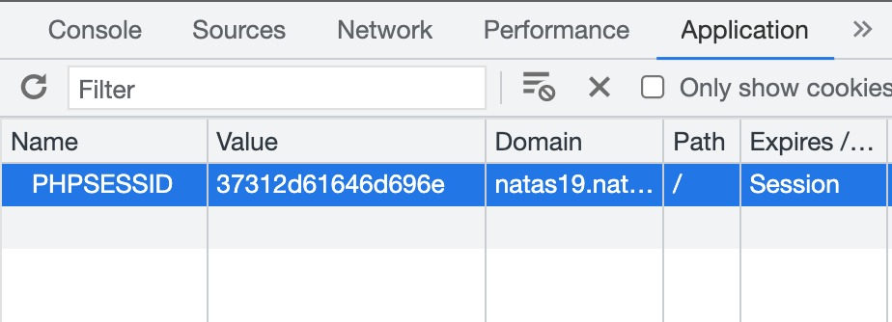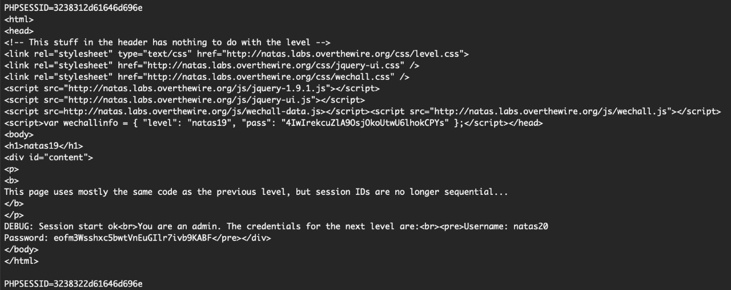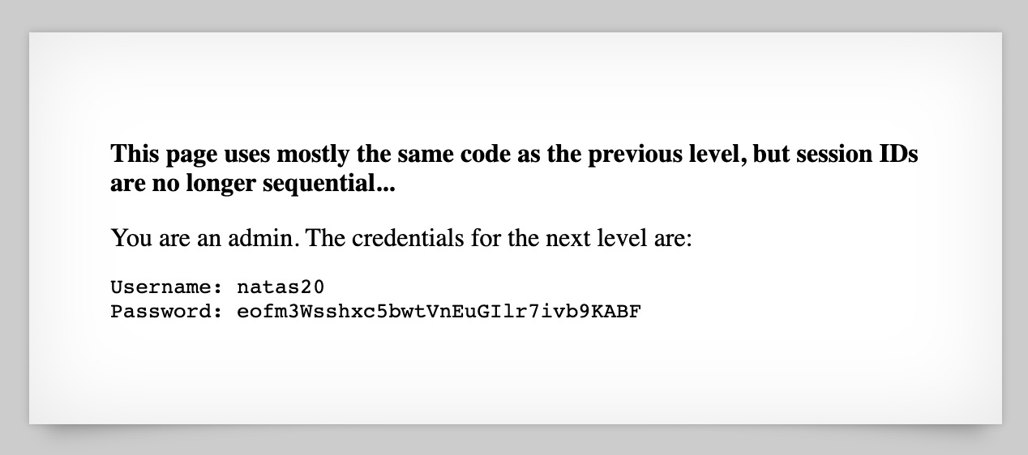

* **NATAS Level 20 → Level 21**

**Step 1: Open** [**http://natas20.natas.labs.overthewire.org**](http://natas20.natas.labs.overthewire.org)

**Step 2: Exploit race conditions.**

**Password Found: IFekPyrQXftziDEsUr3x21sYuahypdgJ**

**Logic:** **Session handling and race attacks.**

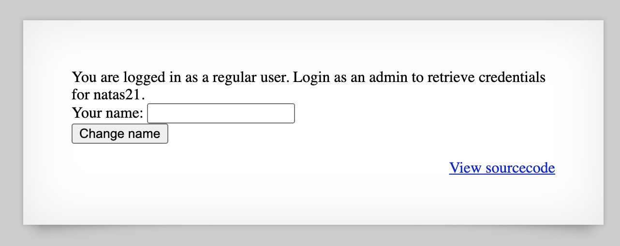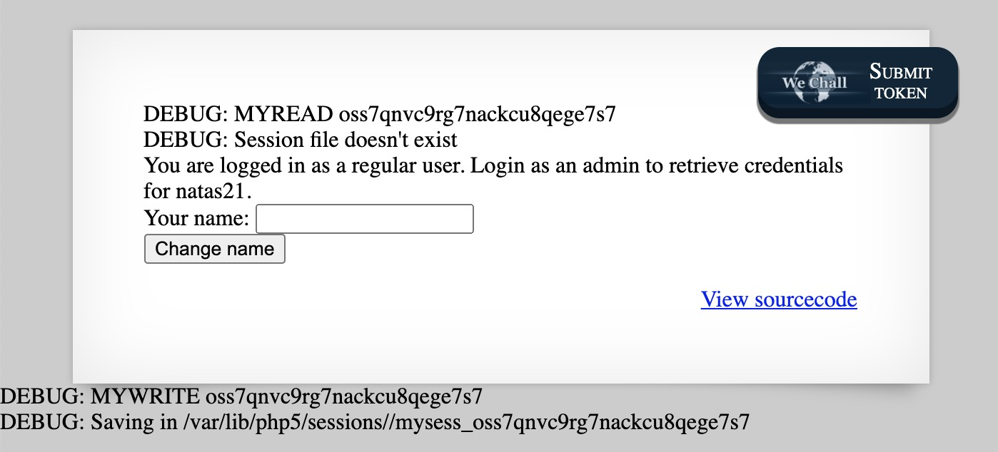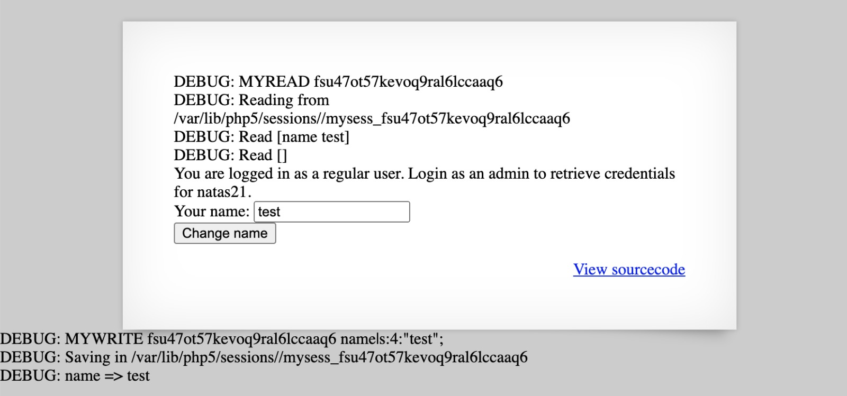

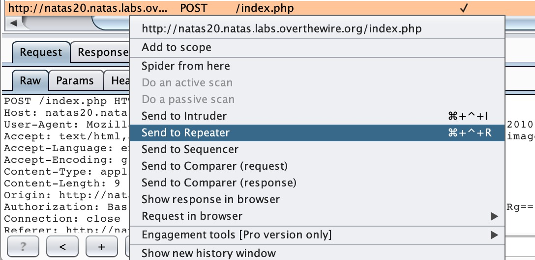

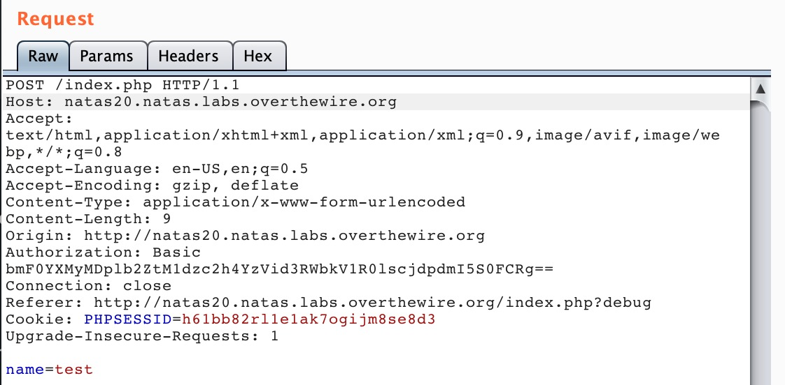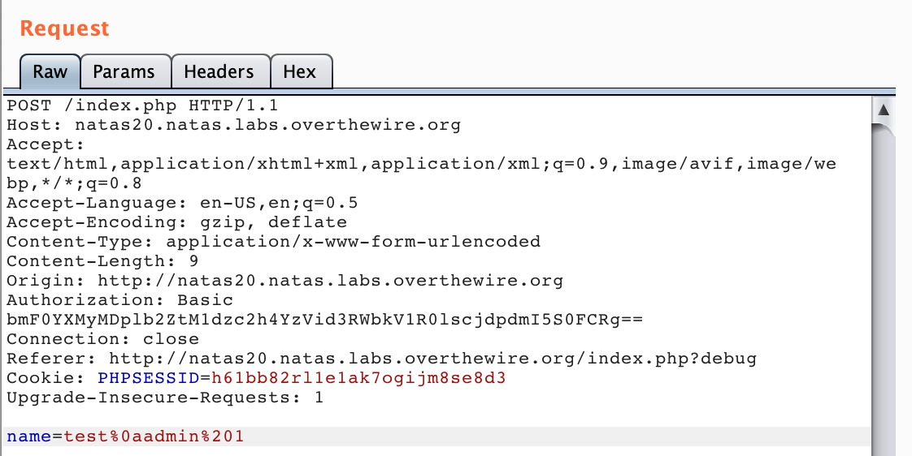

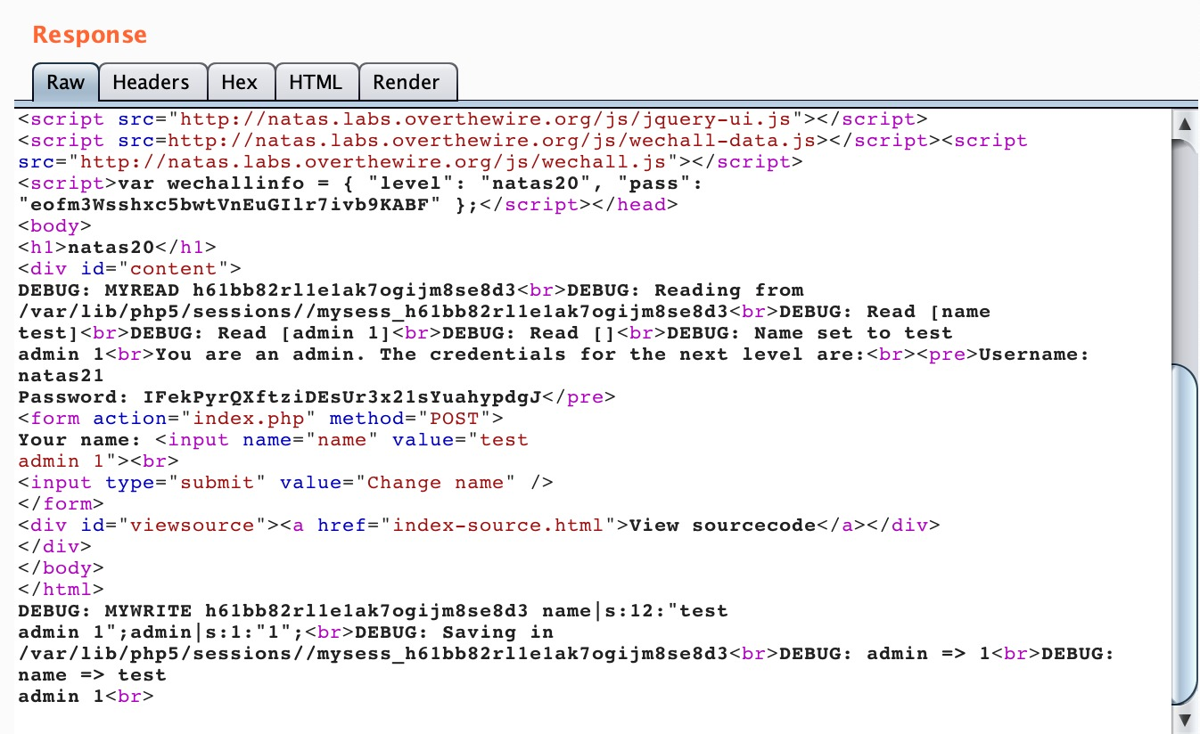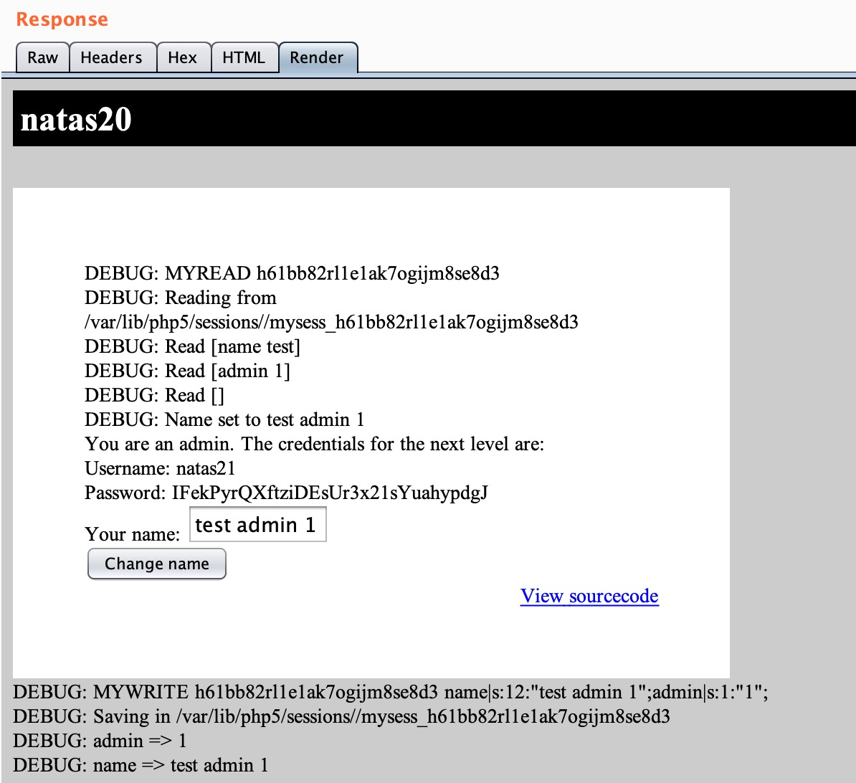

* **NATAS Level 21 → Level 22**

**Step 1: Open** [**http://natas21.natas.labs.overthewire.org**](http://natas21.natas.labs.overthewire.org)

**Step 2: Find connection between two sites (main site and internal site).**

**Password Found: chG9fbe1Tq2eWVMgjYYD1MsfIvN461kJ**

**Logic: Cross-site referencing.**

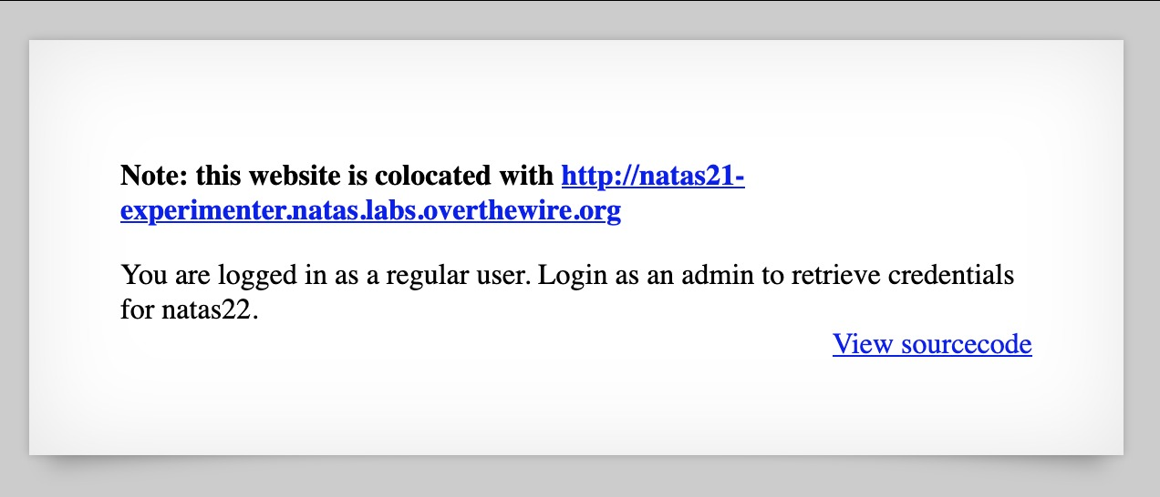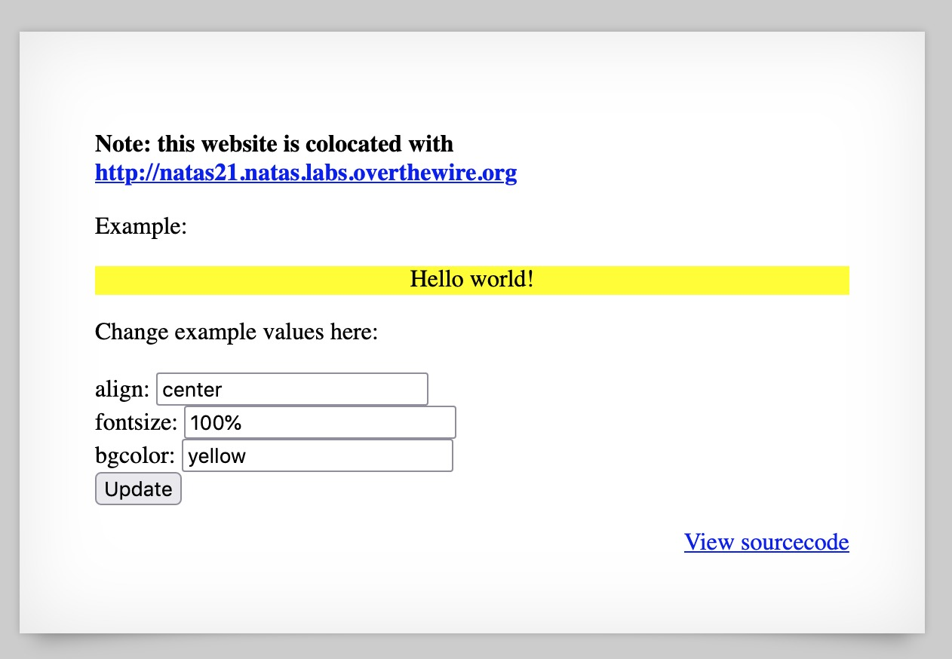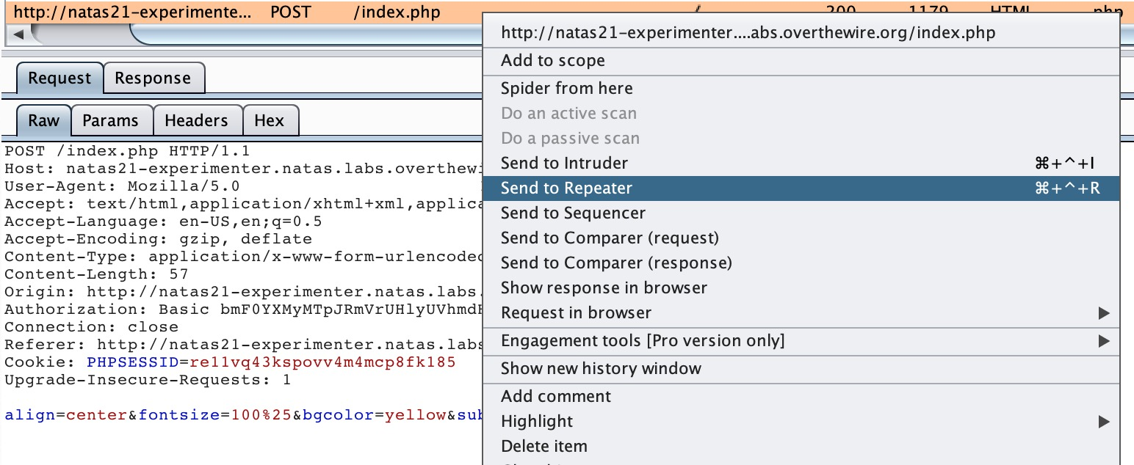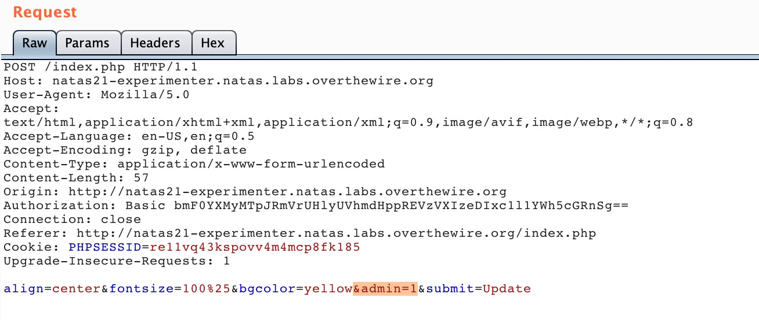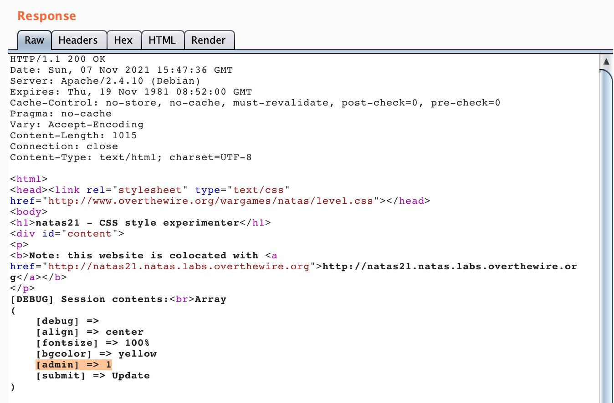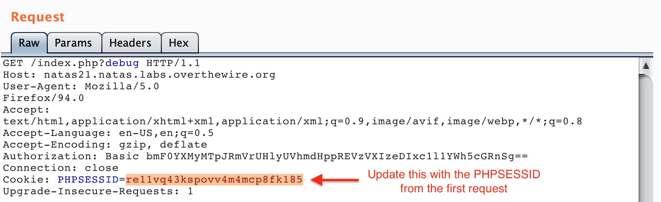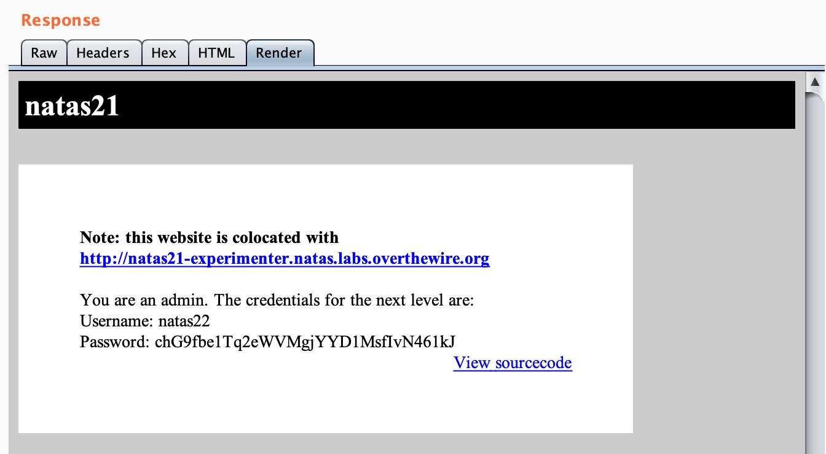

* **NATAS Level 22 → Level 23**

**Step 1: Open** [**http://natas22.natas.labs.overthewire.org**](http://natas22.natas.labs.overthewire.org)

**Step 2: URL redirection manipulation.**

**Password Found: D0vlad33nQF0Hz2EP255TP5wSW9ZsRSE**

**Logic: Handle redirects manually.**

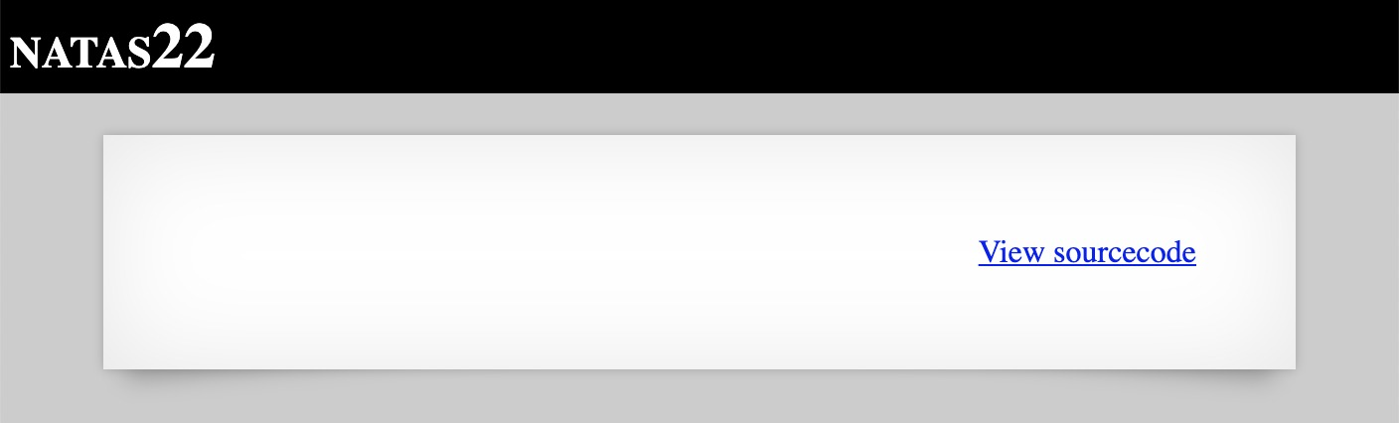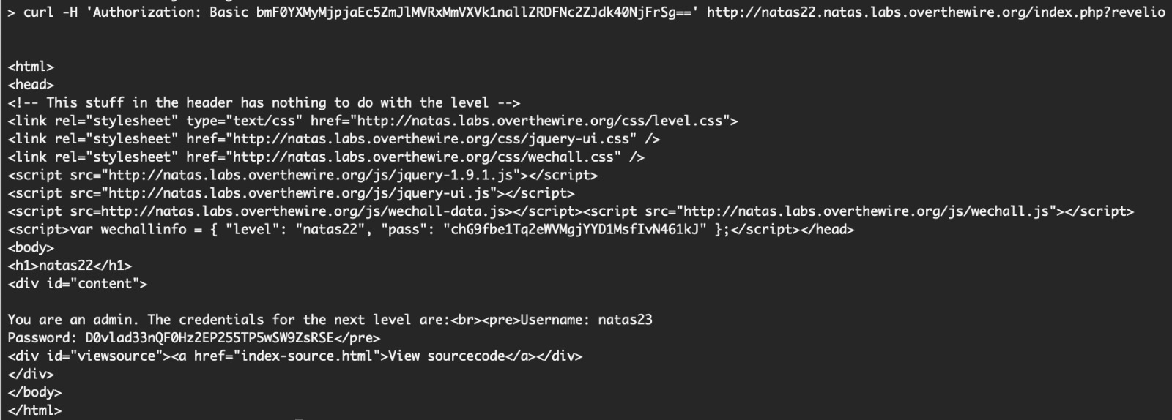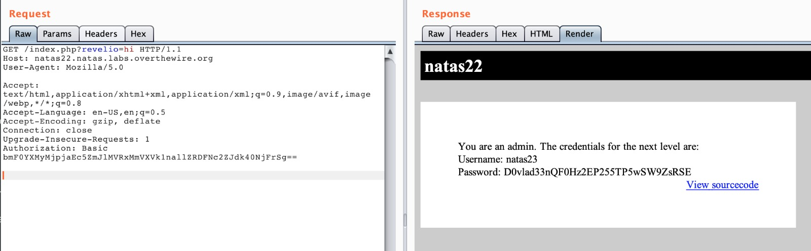

* **NATAS Level 23 → Level 24**

**Step 1: Open** [**http://natas23.natas.labs.overthewire.org**](http://natas23.natas.labs.overthewire.org)

**Step 2: Find hidden hints in the URL encoding tricks.**

**Password Found:** **OsRmXFguozKpTZZ5X14zNO43379LZveg**

**Logic: Understand URL encoding issues.**

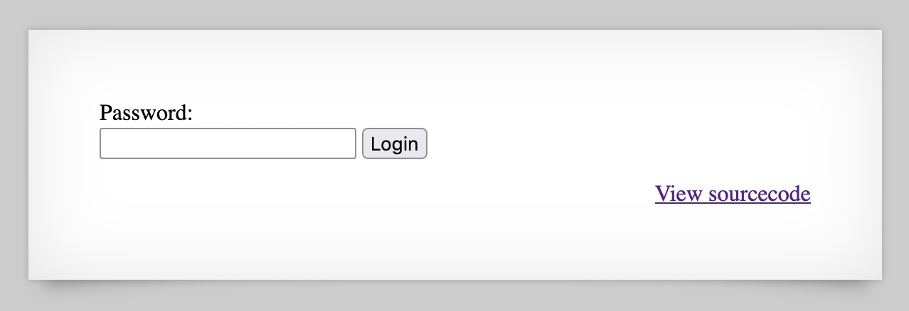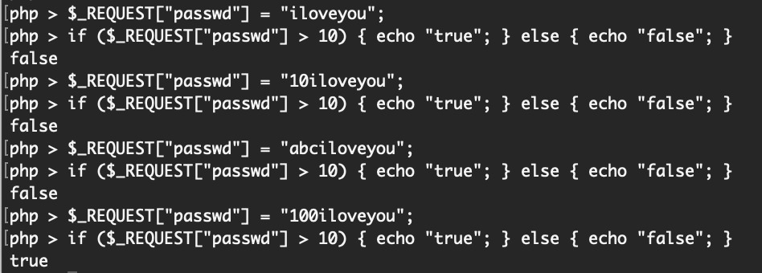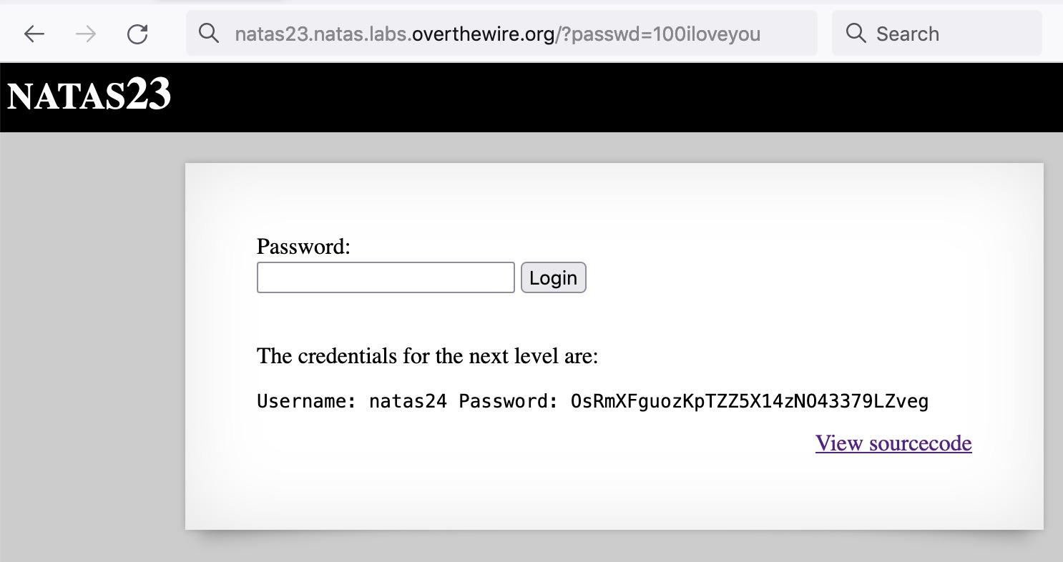

* **NATAS Level 24 → Level 25**

**Step 1: Open** [**http://natas24.natas.labs.overthewire.org**](http://natas24.natas.labs.overthewire.org)

**Step 2: Exploit PHP type juggling (loose comparison).**

**Password Found: GHF6X7YwACaYYssHVY05cFq83hRktl4c**

**Logic: Type juggling exploit in PHP.**

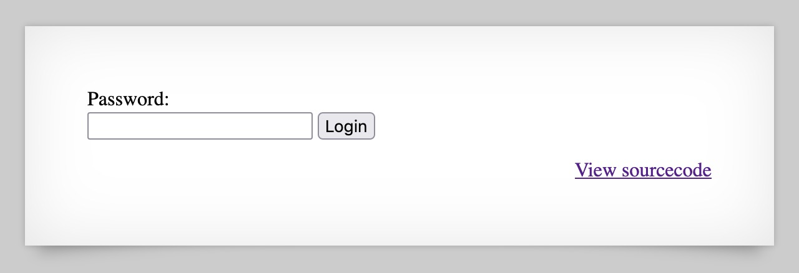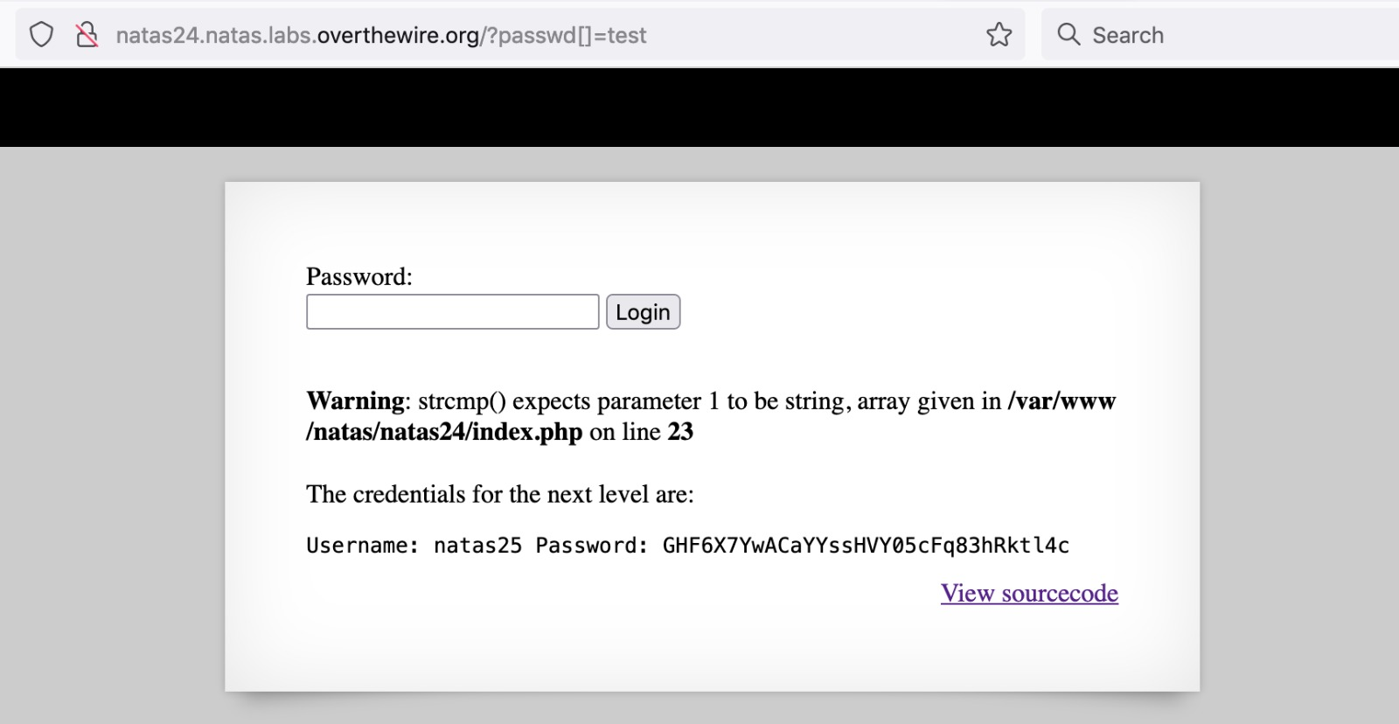

* **NATAS Level 25 → Level 26**

**Step 1: Open** [**http://natas25.natas.labs.overthewire.org**](http://natas25.natas.labs.overthewire.org)

**Step 2: Local File Inclusion attack (LFI).**

**Password Found: oGgWAJ7zcGT28vYazGo4rkhOPDhBu34T**

**Logic: Exploit LFI to read server files.**

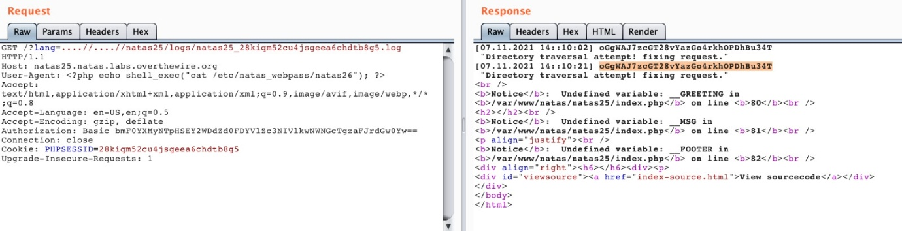

* **NATAS Level 26 → Level 27**

**Step 1: Open** [**http://natas26.natas.labs.overthewire.org**](http://natas26.natas.labs.overthewire.org)

**Step 2: PHP Object Injection.**

**Password Found: 55TBjpPZUUJgVP5b3BnbG6ON9uDPVzCJ**

**Logic: Craft malicious serialized PHP objects.**

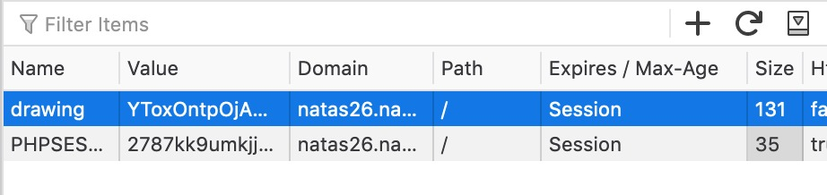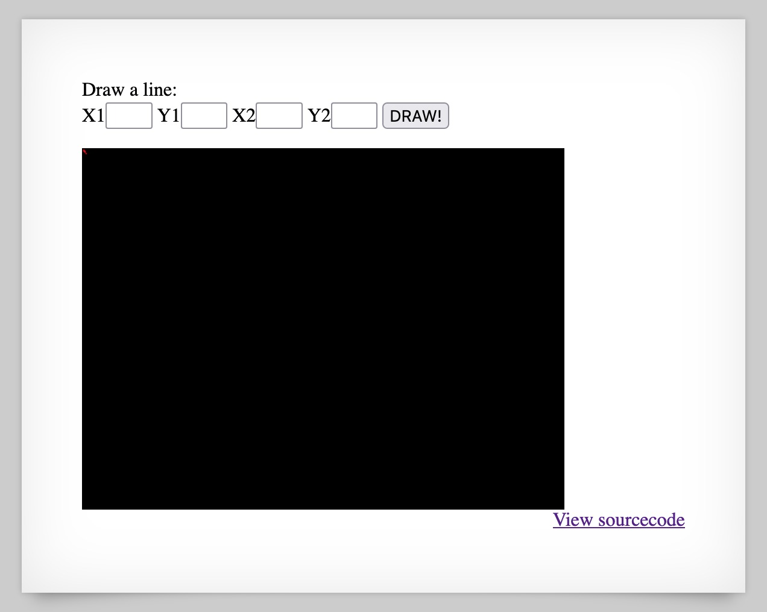

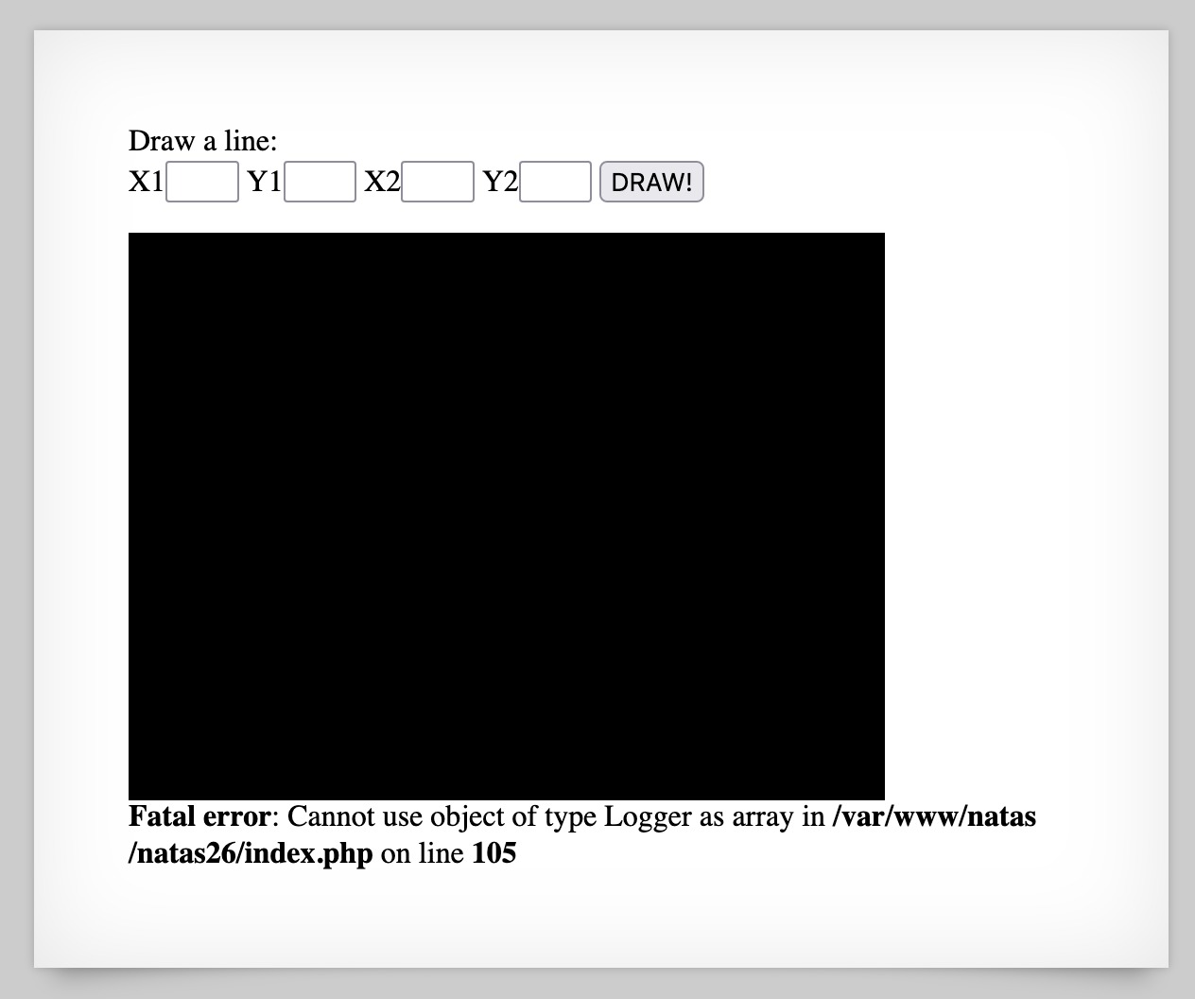

* **NATAS Level 27 → Level 28**

**Step 1: Open http://natas27.natas.labs.overthewire.org**

**Step 2: Bypass authentication using string length tricks.**

**Password Found:** **JWwR438wkgTsNKBbcJoowyysdM82YjeF**

**Logic: Exploit truncation or comparison issues.**

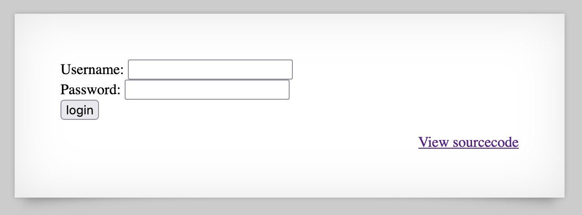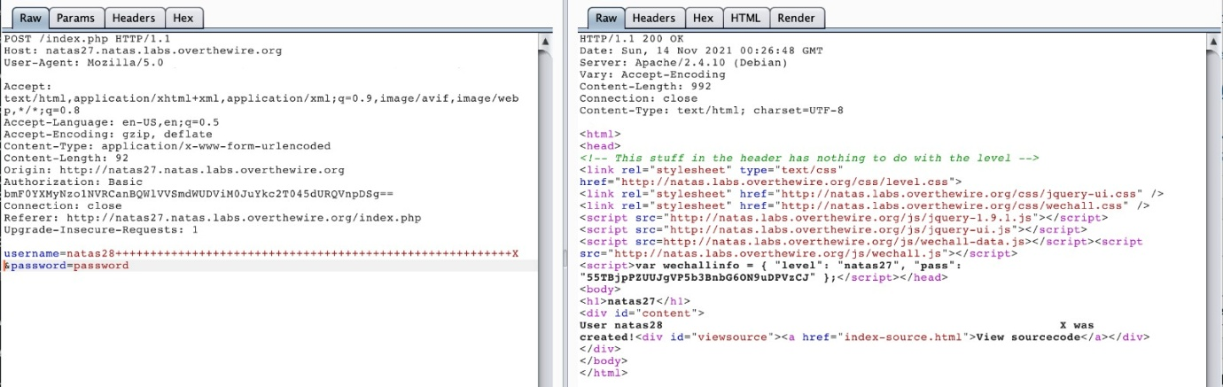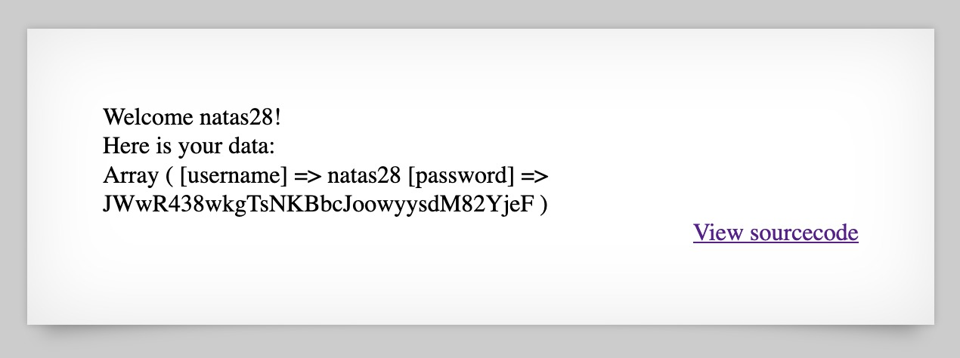

* **NATAS Level 28 → Level 29**

**Step 1: Open** [**http://natas28.natas.labs.overthewire.org**](http://natas28.natas.labs.overthewire.org)

**Step 2: SQL Injection in a prepared statement (logic error).**

**Password Found:** **airooCaiseiyee8he8xongien9euhe8b**

**Logic: Exploit application logic mistakes.**

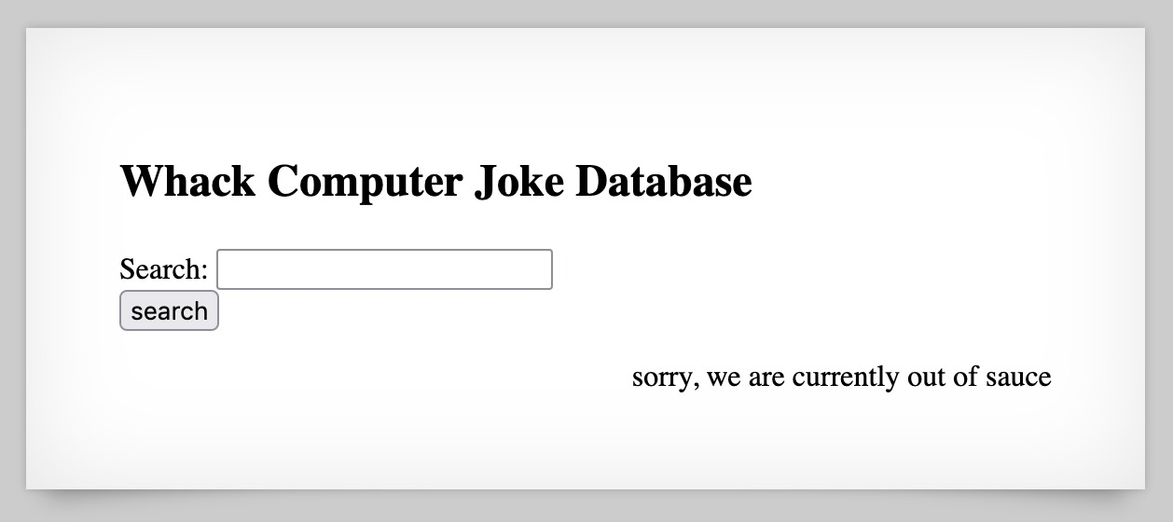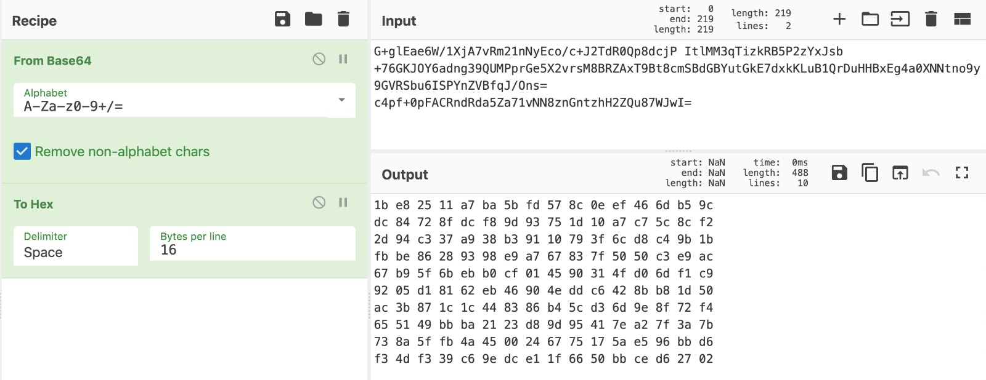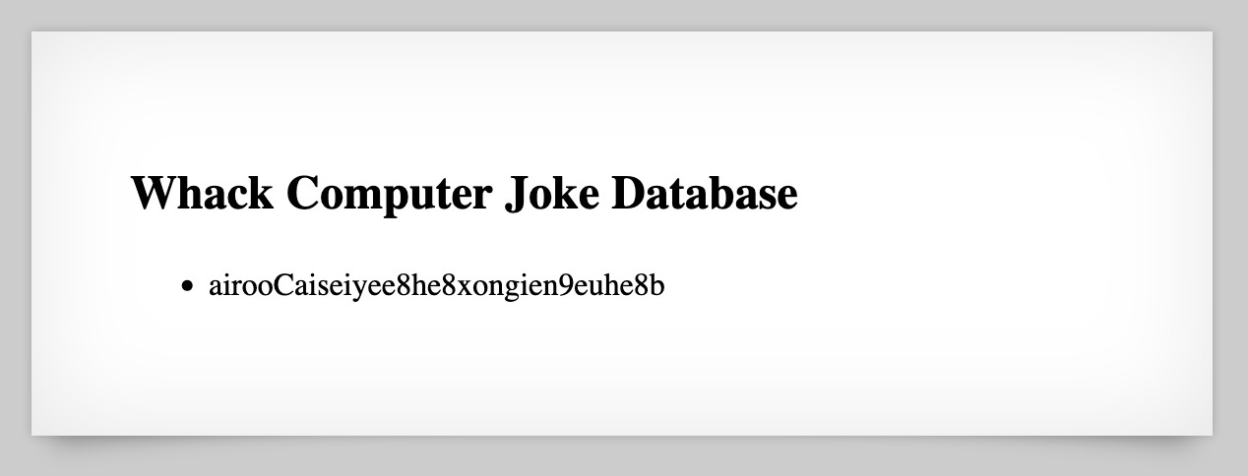

* **NATAS Level 29 → Level 30**

**Step 1: Open** [**http://natas29.natas.labs.overthewire.org**](http://natas29.natas.labs.overthewire.org)

**Step 2: Manipulate encoding/decoding functions.**

**Password Found: wie9iexae0Daihohv8vuu3cei9wahf0e**

**Logic: Encoding mismatch.**

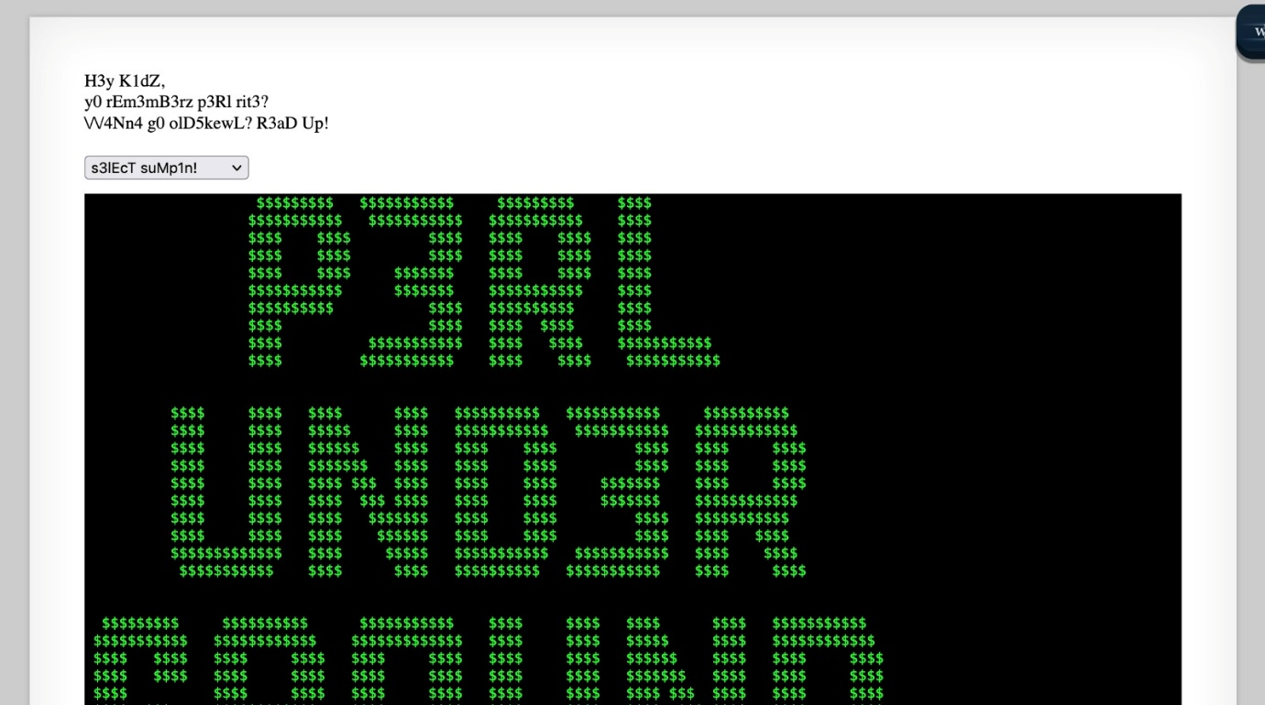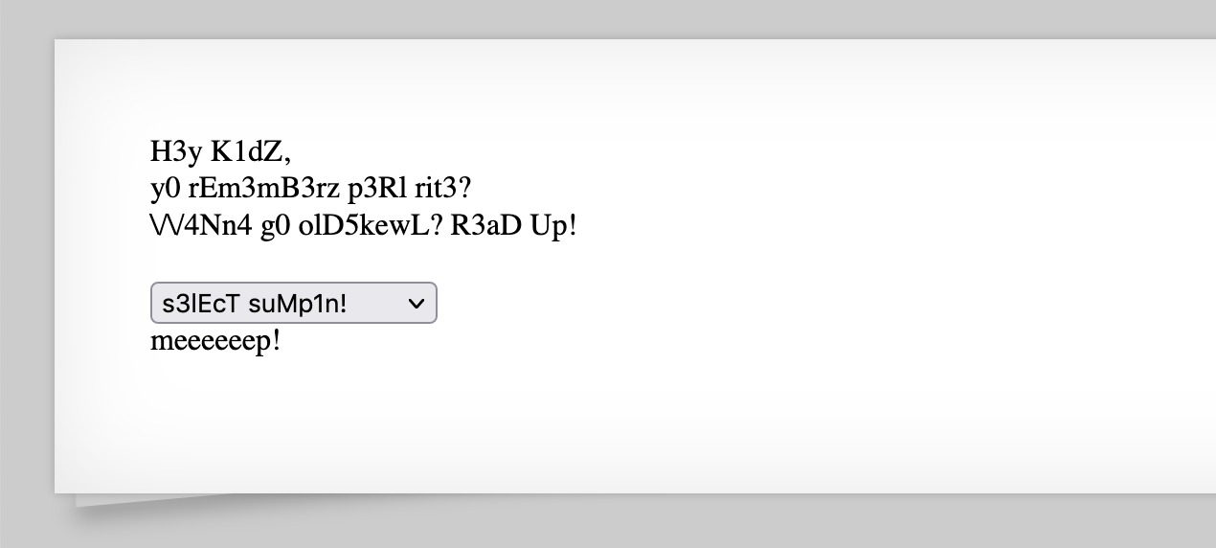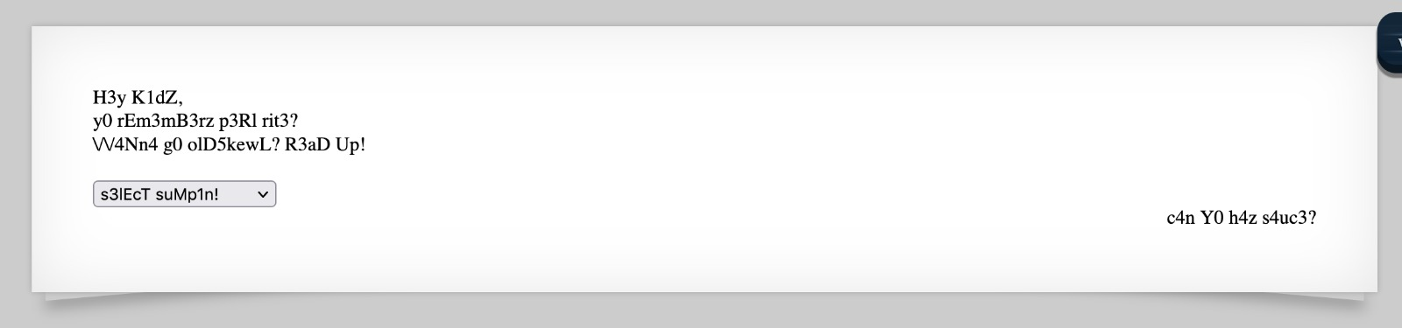

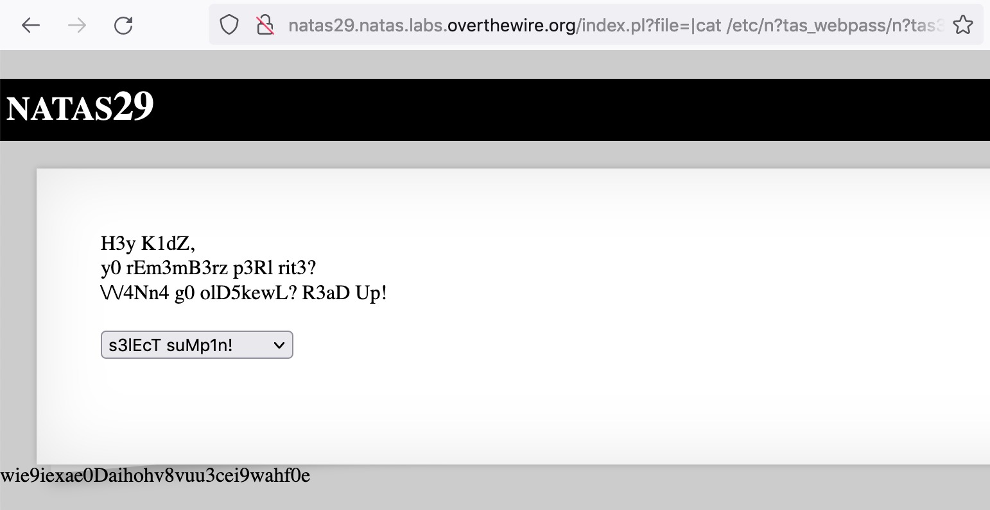

* **NATAS Level 30 → Level 31**

**Step 1: Open** [**http://natas30.natas.labs.overthewire.org**](http://natas30.natas.labs.overthewire.org)

**Step 2: Trick application using crafted request parameters.**

**Password Found:** **hay7aecuungiuKaezuathuk9biin0pu1**

**Logic: Parameter tampering.**

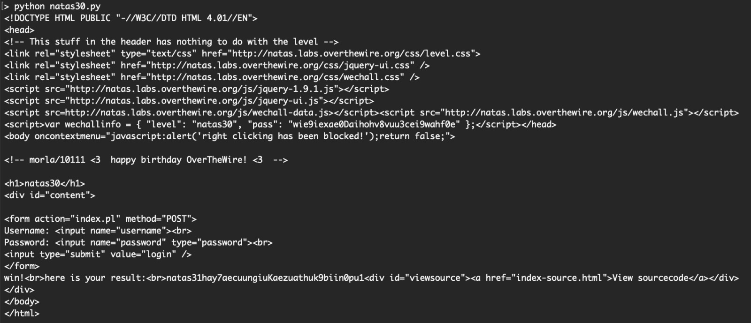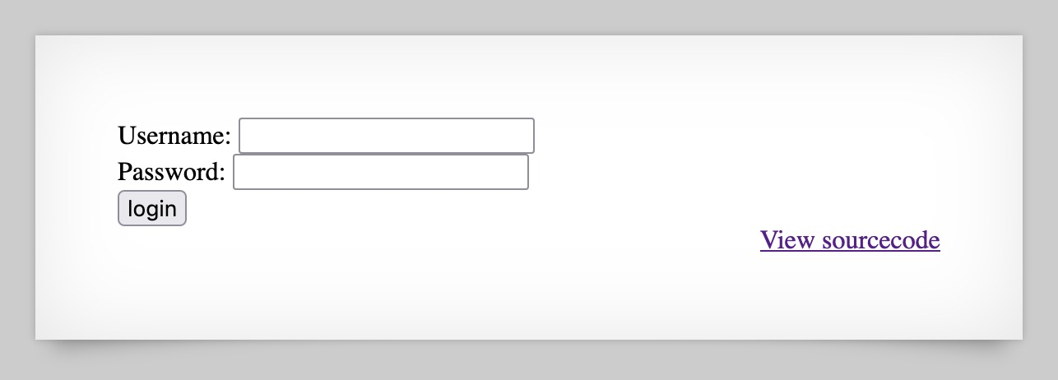

* **NATAS Level 31 → Level 32**

**Step 1: Open** [**http://natas31.natas.labs.overthewire.org**](http://natas31.natas.labs.overthewire.org)

**Step 2: Chain vulnerabilities from previous levels.**

**Password Found:** **no1vohsheCaiv3ieH4em1ahchisainge**

**Logic: Combined exploitation.**

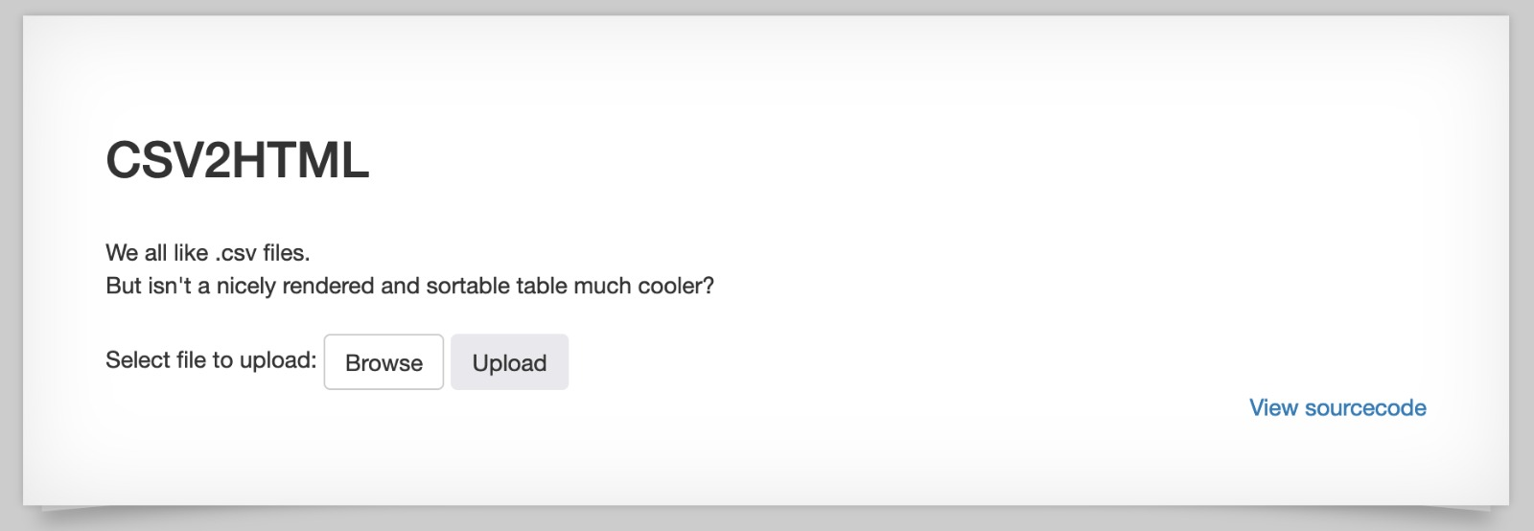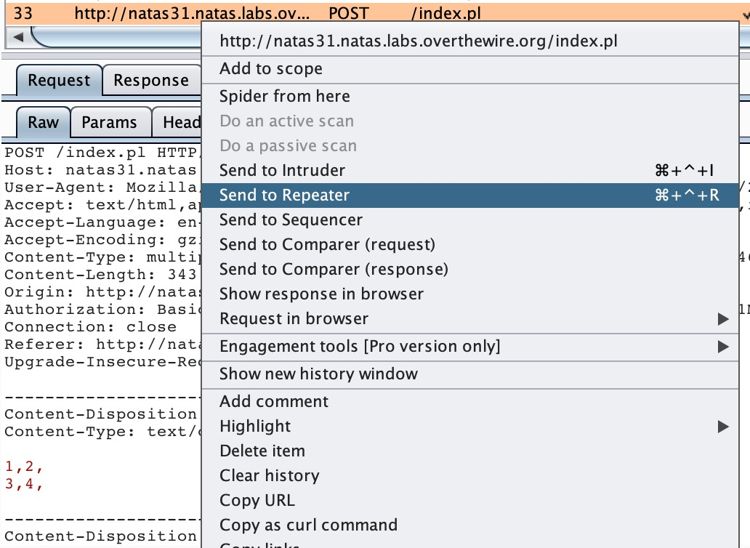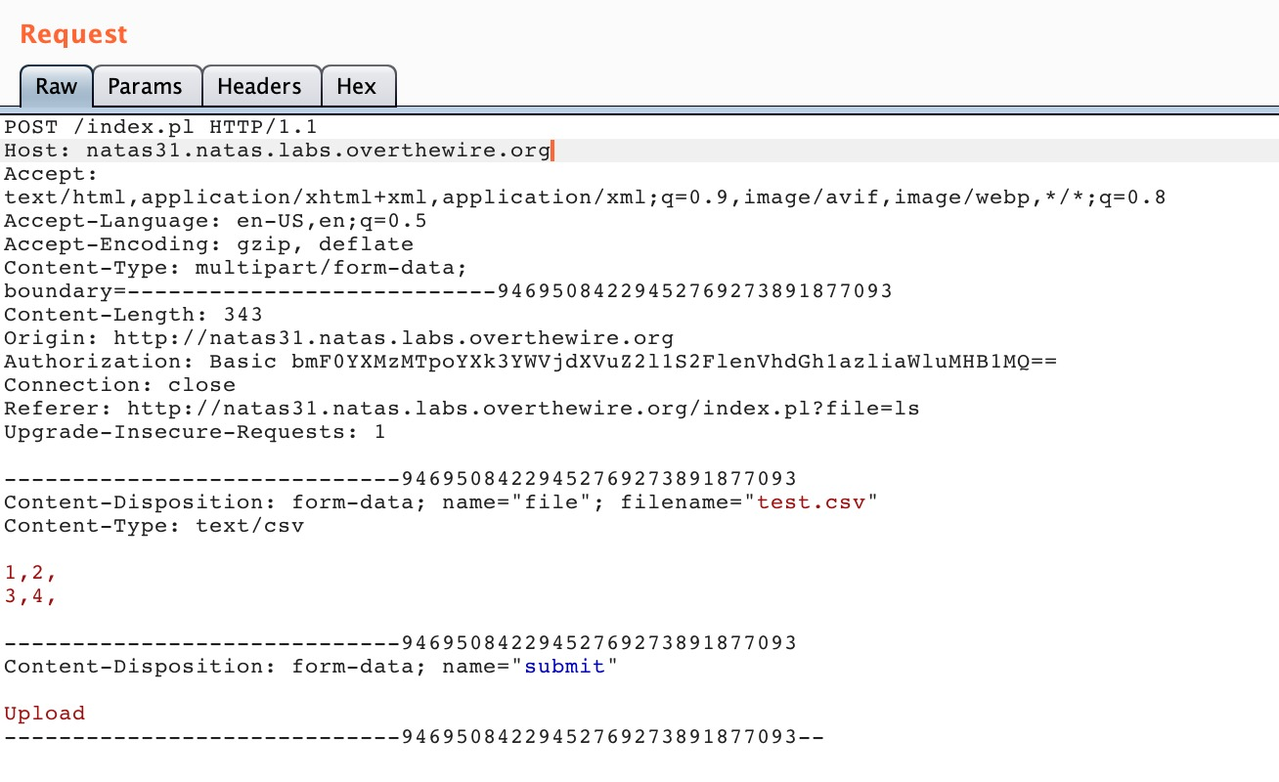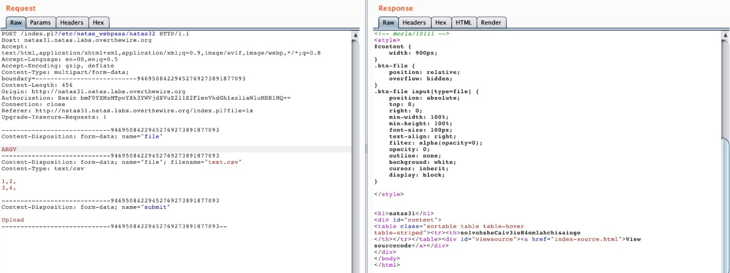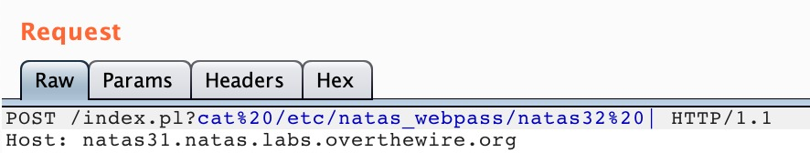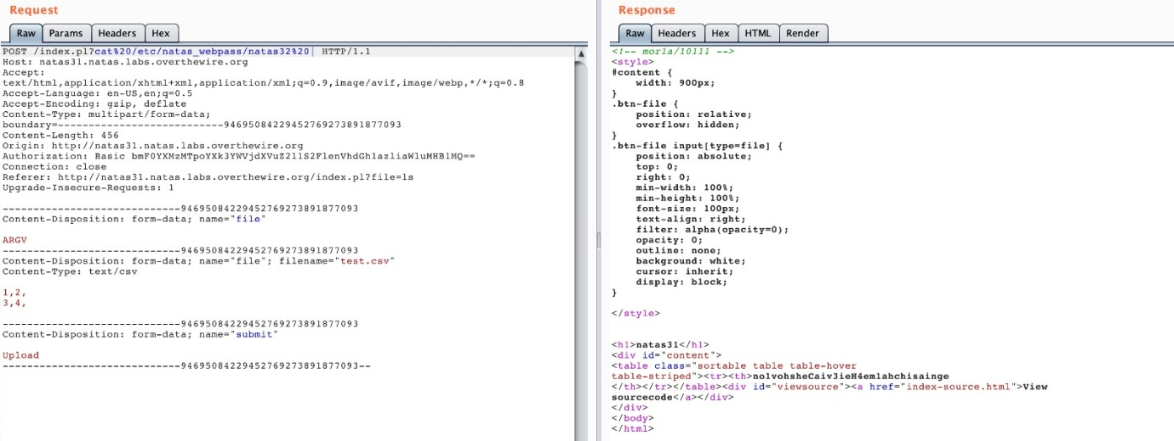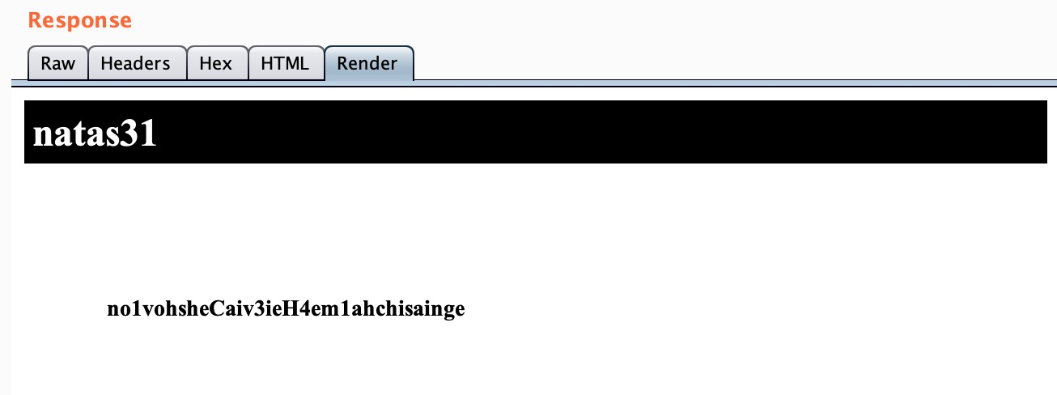

**NATAS Level 32 → Level 33 (Final)**

**Step 1: Open** [**http://natas32.natas.labs.overthewire.org**](http://natas32.natas.labs.overthewire.org)

**Step 2: Use everything learned — upload, inject, bypass.**

**Password Found:** **shoogeiGa2yee3de6Aex8uaXeech5eey**

**Logic: Advanced web exploitation**

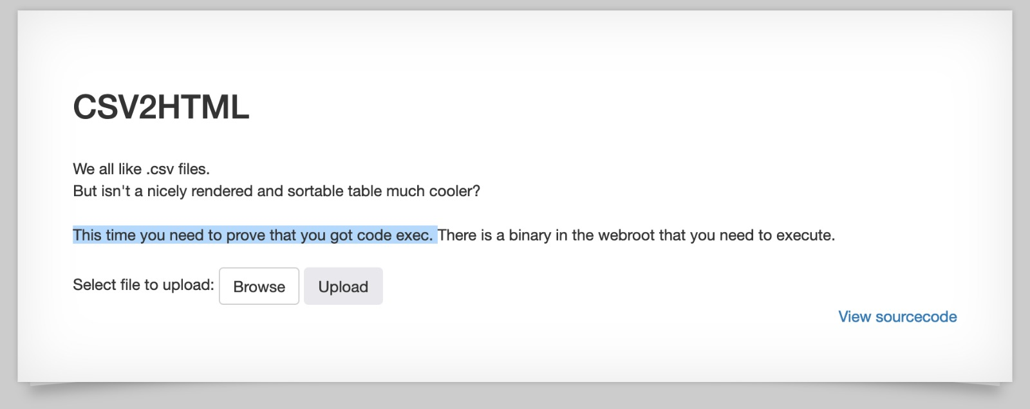

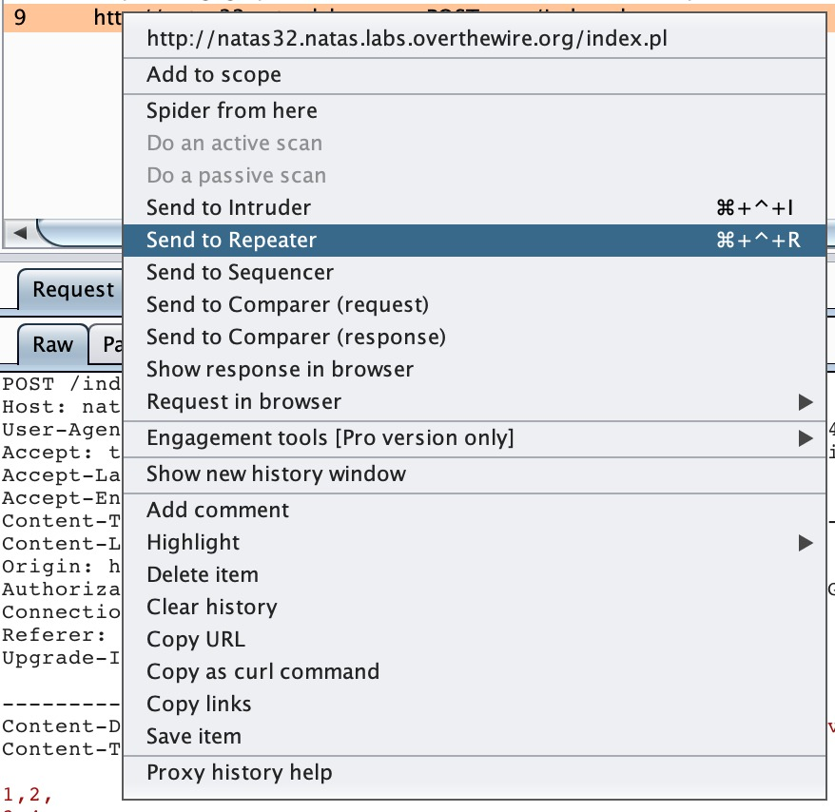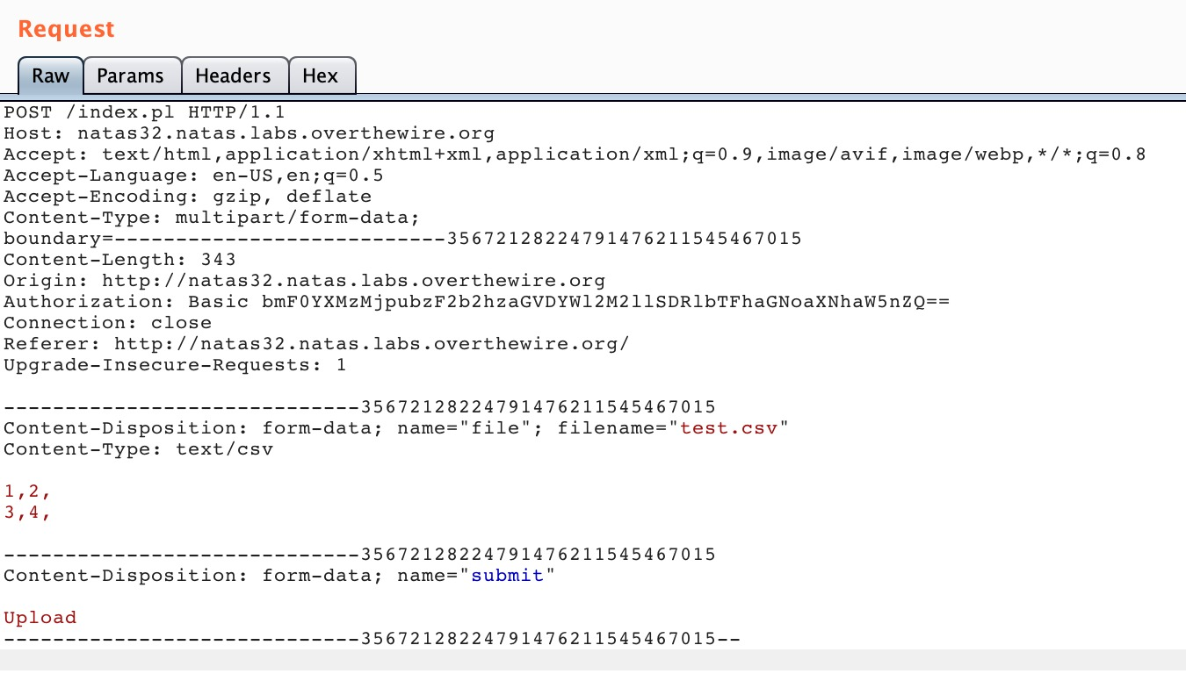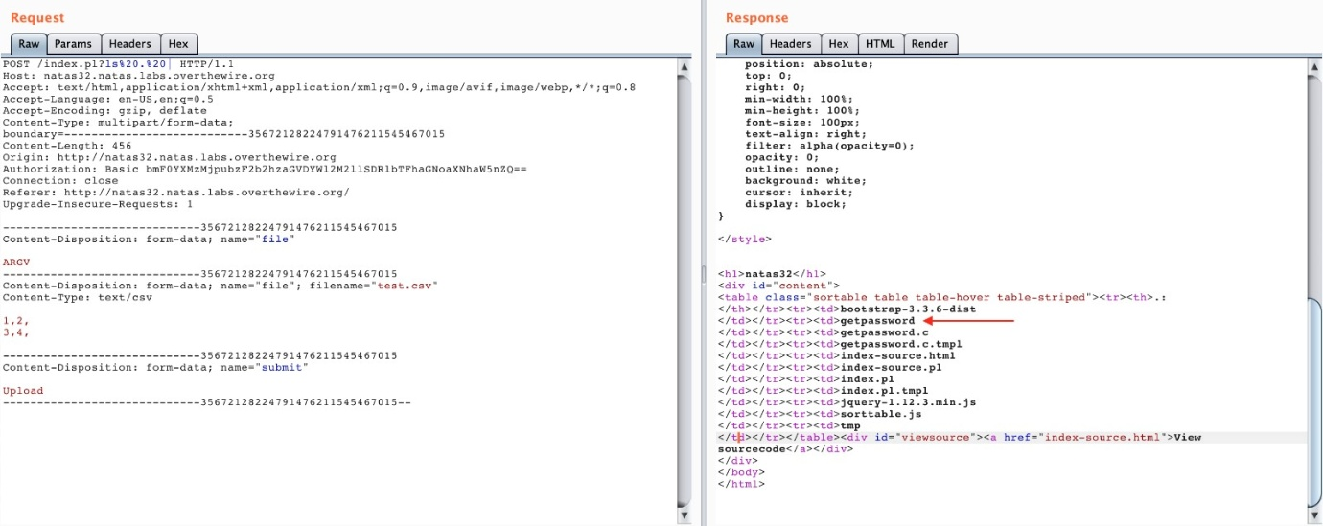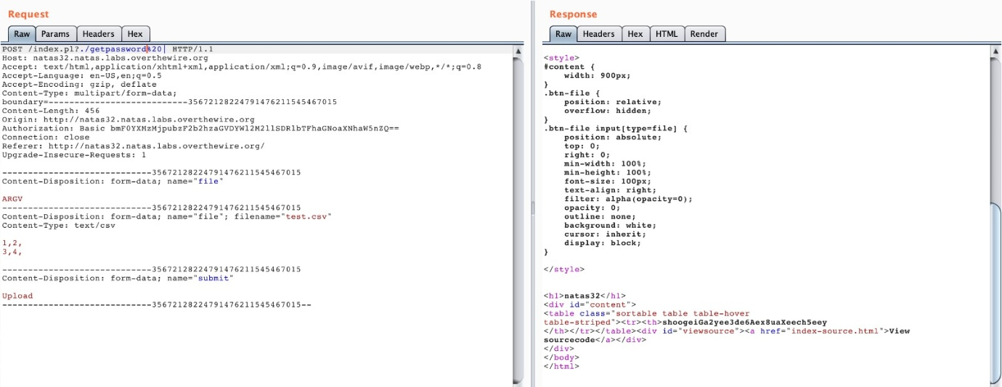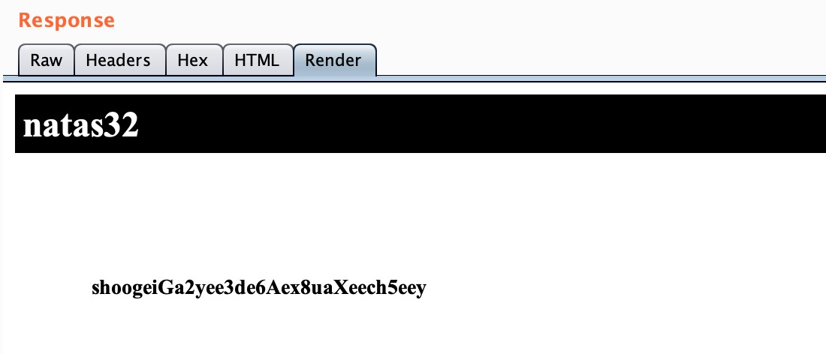

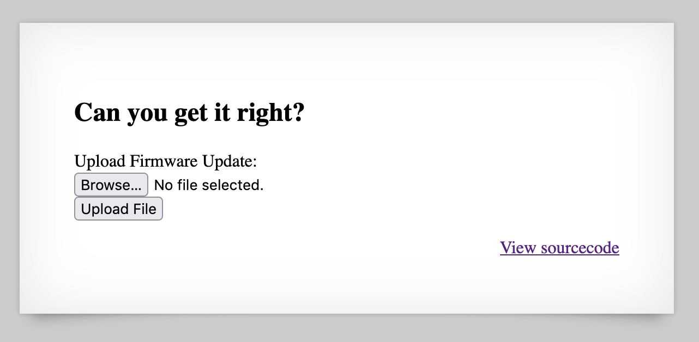

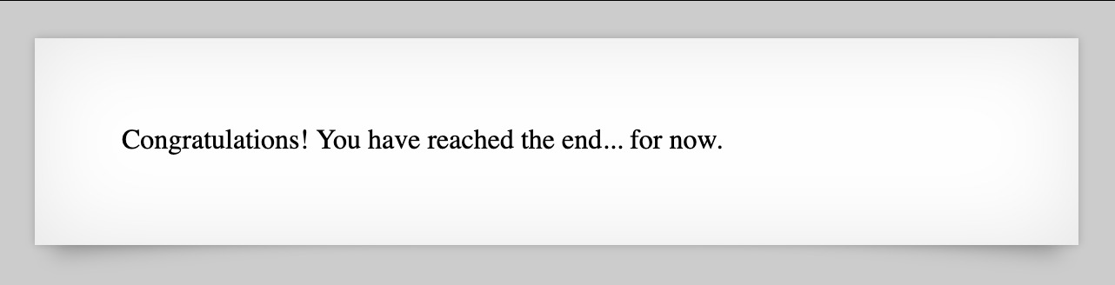

**3.LEVIATHAN -** [**https://overthewire.org/wargames/natas/**](https://overthewire.org/wargames/natas/)

**Tool: Leviathan done in Command Prompt**

* **Leviathan Level 0 → Level 1**

**Tools Used:**

ls, strings, ./binary

**Step 1: Connect to ssh leviathan0@leviathan.labs.overthewire.org -p 2223**

**Step 2: Enter the password (It is given in the OverTheWire website)**

**Step 3: Ran strings check to reveal readable strings inside the binary**

**Step4: Explore the files using commands like ls, cat, and strings to find a hidden password.**

**Password Found: sex**

**Step 5: Executed pw to binary i.e. ./check sex**

**Logic: Look for readable strings or hidden passwords in executable files.**

**PW FOUND:** **NsN1HwFoyN**

* **Leviathan Level 1 → Level 2**

**Tools Used:**

•./binary, file path manipulation

**Step 1: Enter ssh leviathan1@leviathan.labs.overthewire.org -p 2223**

**Step 2: Use the password you found in Level 0.**

**Step 3: Find setuid files (find / -user leviathan1 -perm -4000 2>/dev/null) and run them carefully.**

**Logic: Understand privilege escalation via setuid files.**

**Password Found: f0n8h2iWLP**

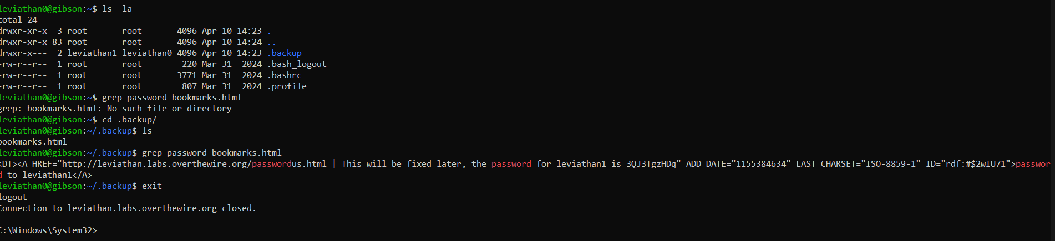

* **Leviathan Level 2 → Level 3**

**Objective: Bypass filename filtering using symbolic links.**

**Tools Used:**

•ln -s, ./binary

**Step 1:** **Enter ssh leviathan2@leviathan.labs.overthewire.org -p 2223**

**Step 2: Use the password found from Level 1.**

**Step 3: Identify interesting files and run them. If needed, input specific values (for example, passwords) when prompted.**

**Logic: Sometimes programs ask for input — observe and guess smartly.**

**Password Found: WG1egElCvO**

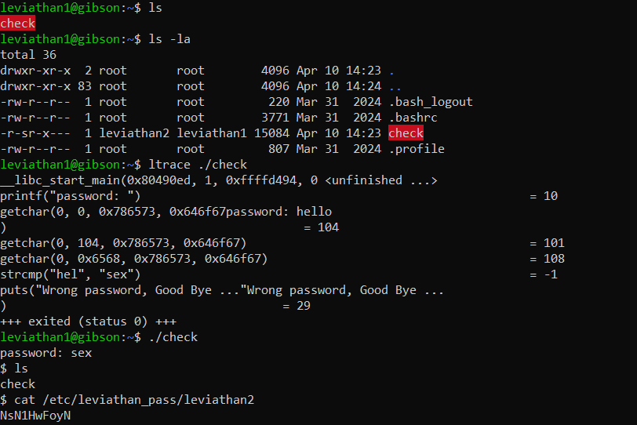

* **Leviathan Level 3 → Level 4**

**Tools Used:**

•Bash scripting, brute-force loop

**Objective:** Find a 4-digit PIN to reveal the next password.

**Step 1: Enter ssh leviathan3@leviathan.labs.overthewire.org -p 2223**

**Step 2: Use the password found from Level 2.**

**Step 3: Use ltrace, strace, or strings to see what the binary is doing.**

**Logic: Use debugging tools to intercept function calls or find passwords inside binaries.**

**Password Found: 0dyxT7F4QD**

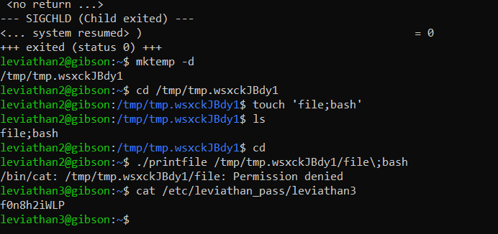

* **Leviathan Level 4 → Level 5**

**Tools Used:**

•find, file, SUID analysis

**Objective:** Find and exploit a SUID binary.

**Step 1: Enter ssh leviathan4@leviathan.labs.overthewire.org -p 2223**

**Step 2: Use the password found from Level 3.**

**Step 3: Use simple guessing or brute force based on hints. Some levels have tiny password files.**

**Logic: Wordlist or brute-forcing ideas.**

**Password Found: szo7HDB88w**

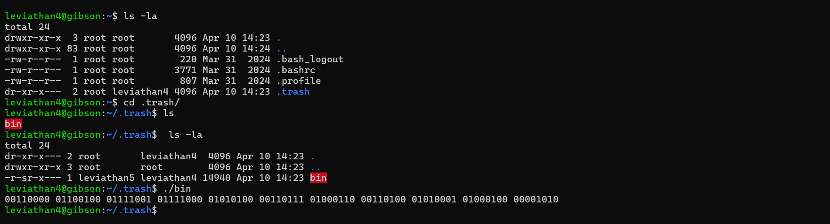

* **Leviathan Level 5 → Level 6**

**Tools Used:**

•ltrace, strings, function tracing

**Objective:** Trace the binary to find how it compares input to a password.

**Step 1: Enter ssh leviathan5@leviathan.labs.overthewire.org -p 2223**

**Step 2: Use the password found from Level 4.**

**Step 3: Check executables and see if any file input tricks (like providing filenames) help extract the next password.**

**Logic: Understand file handling vulnerabilities.**

**Password Found: qEs5Io5yM8**

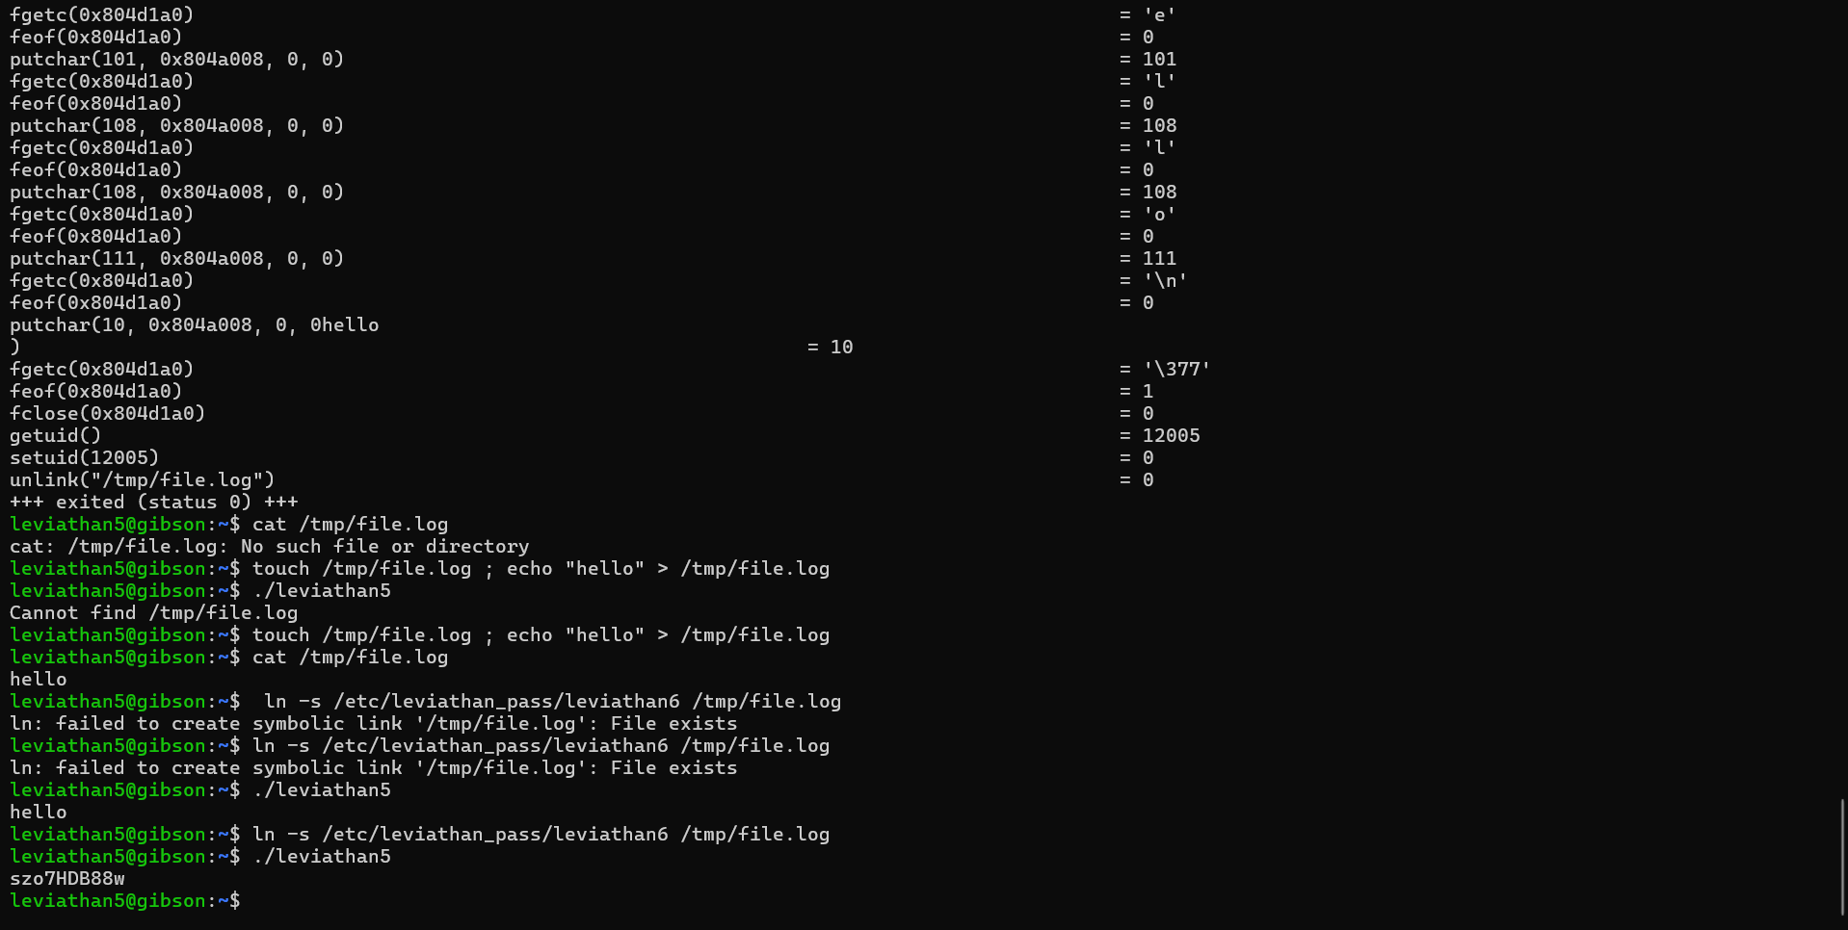

* **Leviathan Level 6 → Level 7**

**Tools Used:**

•strings, environment variable manipulation

**Objective:** Use a binary that relies on environment or paths to run external commands.

**Step 1: ssh leviathan6@leviathan.labs.overthewire.org -p 2223**

**Step 2: Use the password found from Level 5.**

**Step 3:** **Explore executables or hidden files, and understand how file permissions work.**

**Logic: Check file permissions and leverage them.**

